**ABSTRACT**

This project main aim is to handle thousands of requests (traffic load) on a web portal when millions of users want to access the same webpage. When the user hits on a certain URL and if the requests are more on that URL the traffic load will be more. There will be lagging of the site and can’t be accessed by all the users at a time, to avoid this problem we are going to change the existing policies in AWS Cloud, and create virtual instance servers by using AWS.

The main objective of this project is to maintain auto-scaling and load balancing on a certain web portal. In Load Balancers, Elastic Load Balancing automatically distributes your incoming traffic across multiple targets, such as EC2 instances. Auto-scaling monitors your applications and automatically adjusts capacity to maintain steady and better performance at the lowest cost. Network security consists of the policies and practices to prevent and monitor unauthorized access, misuse, modification, or denial of a computer network and network-accessible resources.

Network security consists of the policies and practices to prevent and monitor unauthorized access, misuse, modification, or denial of a computer network and network-accessible resources. Only Network security can protect you from Trojan horse viruses. Network security involves the authorization of access to data in a system, controlled by the network administrator. To avoid ARP SPOOFING, MAC FLOODING, and DHCP SPOOFING, we implement security policies. Firewall plays a preeminent role in network security. To prevent unauthorized access, we are using Cisco advanced security appliances. To connect different branches with security, we are implementing SITE TO SITE VPN. To overcome the network attacks, we are developing the Intrusion Prevention System. Cisco IOS Intrusion Prevention System (IPS) is an inline, deep-packet inspection feature that effectively mitigates a wide range of network attacks. These network security infrastructure is implementing in On-premises, not in a cloud

**ACKNOWLEDGMENT**

We feel thankful to our **P Bala Srinivas** Sir of Aditya College Of Engineering, for his cooperation and help in the completion of our project and throughout our course.

We avail this opportunity to express our heartfelt thanks to our HOD VV Satya Narayana Sir and principal Dr. Srinivas Reddy Sir of Aditya Engineering College, and to the management for providing a great support for our project completion.

**Y. Kranthi (16A95a0436)**

**N. Sudha (15A91A04G1)**

**B. Amit (15A91A04C3)**

**G.Indrani (16A95A0429)**

**DECLARATION**

We hereby declare that this project entitled “AWS CLOUD & NETWORK SECURITY” has been undertaken by us and this work has been submitted to ADITYA COLLEGE OF ENGINEERING affiliated to J.N.T.U Kakinada, in partial fulfillment of the requirements for the award of the degree of Bachelor of Technology in Computer Science & Engineering.

We declare that our project entitled “AWS CLOUD & NETWORK SECURITY” is not submitted in any university.

**Project Associates**

Y. Kranthi (16A95a0436)

N. Sudha (15A91A04G1)

B. Amit (15A91A04C3)

G.Indrani (16A95A0429)

**INDEX**

Page Numbers

1. INTRODUCTION 1

2. REQUIREMENT ANALYSIS 1-2

2.1 Hardware Requirements.

2.2 Software Requirements

2.3 Services & Platforms

3.SYSTEM ANALYSIS 2

3.1 EXISTING SYSTEM

3.2 PROPOSED SYSTEM

4. SYSTEM DESIGN 2-5

4.1 UML Diagrams

4.1.1 Use Case Diagram

4.1.2 Activity Diagram

4.1.3 Sequence Diagram

5. AWS CLOUD 5-8

5.1 What is AWS and why AWS

6. Website and DB details 9-54

6.1 Main website code 9-28

6.2 IOT web page code 29-31

6.2.1 IoT Introduction 32-37

6.2.2 IoT Ardunio Code 38-43

6.2.3 MQTT Setup 44-46

6.3 Database Creation 46-47

6.3.1 Setting Database Path 47-48

6.3.2 Downloading and Installing Node js 48

6.3.3 Connecting Database to Website 48-49

6.4 Python MQTT Code 50-53

6.5 Storing Atmosphere details into Database tables 53-54

7. Amazon EC2 54-57

7.1 Procedure for running web scripts on server: 57-58

8. Elastic Load Balancer 58-64

9. AUTO SCALING 64-72

10. Network Security 72-85

10.1 DHCP Snooping 72-73

10.2 Implementing Port-Security 73-75

10.3 Securing the Cisco IOS Image and Configuration Files 75

10.4 ARP Dynamic Inspection 76

10.5 Site to Site VPN 77-86

11. Conclusion

**1. INTRODUCTION**

Now days, E-commerce website are very popular. Online shopping Websites plays a major part some of them are Flipkart, Amazon etc.,.

These websites are requesting (or) accessing will be varied based on the timings. For suppose Monday to Friday will get approximately 10,000 requests. On weekends will get 50,000 requests and also on festivals, offers and also big billion day, in these timings will get lakhs of lakhs request. For this website, we have to maintain servers, applications, storage, etc. On weekends load will be normally so it may require to manage 2 or 3 servers. On weekends we require 10 to 100 servers. On offer’s day we have to maintain thousands of servers. Again, we have to buy more servers compare to all others days infrastructure. In normal days we don’t require this much of servers, applications, storage. This much of infra of websites building and managing, it is very difficult.

To overcome this issue, we are moving to cloud. That is AWS Cloud, it is providing a feature called load balancing and Auto scaling. Whatever load is coming to websites, that entire load will be redistributed to all existed servers. When the load is exhausted, to up and run 24x7. AWS increases the servers count, based on the policy. In that policy we have to mention C.P.U percentage. For suppose C.P.U percentage is more than 80% then create 3 more servers and when C.P.U percentage is less than 40% delete the new created servers.

Day by day data is increasing like anything not able to manage with storage clusters like an NFS, SAN, and RAID’S. AWS Database Migration Service helps you migrate databases to AWS quickly and securely.

**2. REQUIREMENT ANALYSIS**

Requirement analysis is a software engineering task that bridges the gap between system level software allocation and software design. It provides system engineer to specify software function and performance indicate software’s interface with the other system elements and establish constraints that software must need.

**2.1 Hardware Requirements:**

Processor: t2, micro

RAM:2GB

HDD:8GB

**Software Requirements:**

Operating System: Amazon Linux

Application server: Apache

Front end: HTML, CSS, Bootstrap

Backend: Nodejs, MySQL

Cisco Networking Devices (Switch and Router)

**2.2 Services and Platforms:**

AWS (VPC, S3, Linux, SSH, Cloud Watch)

Load Balancing

Auto Scaling

**3. SYSTEM ANALYSIS:**

**3.1 EXISTING SYSTEM:**

When the user hits on a certain URL and if the requests are more then there will be increase in the traffic load. There will be lagging of the site and can’t be accessed and there will be unavailability of the URL for the users. If the load on the webpage is more on Big Billion Days for a shopping cart site, then huge loss to the Commercial Applications. Purchasing of physical servers only for one day sale is waste of money and configuring every server day by day is a difficult task to the administrator. Maintenance of servers is difficult. This much of infra of websites building and managing, it is challenging.

**3.2 PROPOSED SYSTEM:**

To overcome this issue, we are moving to the cloud. That is AWS CLOUD, and it is providing a feature called load balancing and Auto scaling. So when the load hits on the websites, then automatically virtual servers are created so that entire load will be redistributed to all servers. When the load is exhausted, to up and run 24x7. AWS increases the servers count, based on the policy.

**4.** **SYSTEM DESIGN**

The architecture or the structure of our project is explained to have a brief idea of how it gets processed to meet the requirements of the user.

**4.1** **UML Diagrams**:

**4.1.1 Use Case Diagram:**

Use case Diagrams represent the functionality of the system from a user’s point of view. Use case focuses on the behaviour of the system from an external point of view.

**Use Case:** Use case describes the behavior of a system. It is used to structure things in a model. It contains multiple scenarios, each of which describes a sequence of actions that is clear enough for outsiders to understand.

**Actor:** An actor represents a coherent set of roles that users of a system play when interacting with the use cases of the system. An actor participates in use cases to accomplish an overall purpose. An actor can represent the role of a human, a device, or any other system.

**Description:** When a commercial client comes to have a deal with an idea for providing the advance maintenance of his data and security policies. He can choose AWS as the better platform. The developer creates web servers to run the commercial website, provides secure login credentials to the user. If the number of users increases beyond the range then load balancing and auto-scaling comes up, the average percentage of c.p.u is calculated and allocates the web instances and remove the instances when the percentage goes down.

**Use Case View**

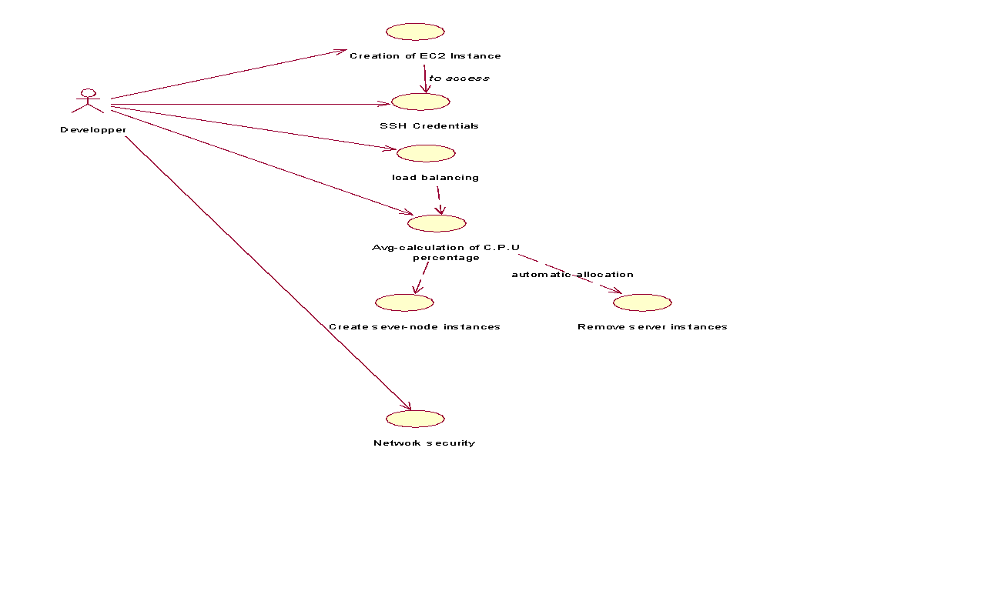

**4.1.2 Activity Diagram:**

Activity diagram illustrates the dynamic nature of a system by modeling the flow of control from activity. An activity represents an operation on some class in the system that results in a change in the state of the system. Typically, activity diagrams are used to model workflow and internal operation.

Action state represents the no interruptible actions of objects. Action flow represents arrows illustrate the relationships among action states.

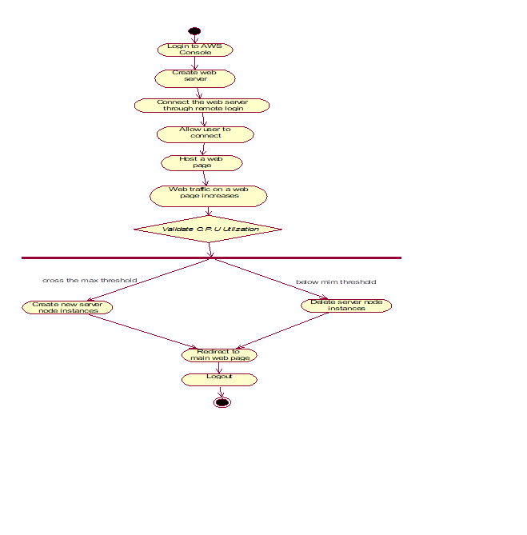

**4.1.3 Sequence Diagram:**

**S**equence diagram describes the pattern of communication among set of interacting objects. An object interacts with other objects by sending messages.The reception of a message by an object triggers the execution of an operation, which in many turn may send messages to other objects.

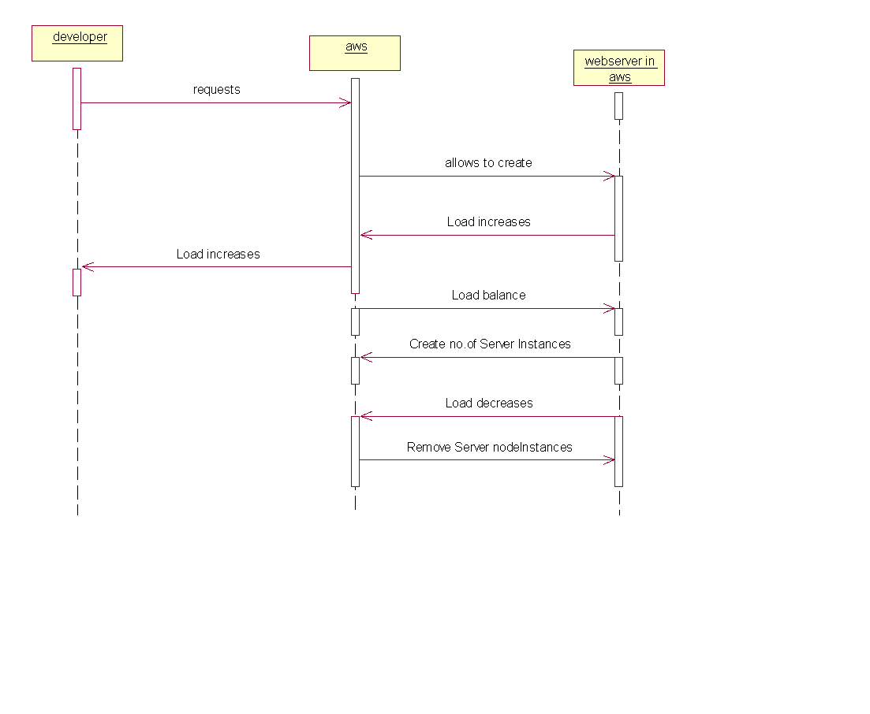**5. AWS**

**Amazon Web Services (AWS)** is owned by Amazon that provides On-demand cloud computing platforms to individuals, companies, and governments, on a paid subscription basis. The technology allows subscribers to have at their disposal a virtual cluster of computers, available at all time through the Internet.

**Why AWS?**

One of the most successful business cloud platforms is amazon web services, it mainly focus on infrastructure as a service. No other cloud vendor will not defeat Aws cloud. Because it is the first invented, what are all the strategy and concept of technology of Aws, Microsoft azure is doing copy and paste. Aws having highest revenue compare to all other clouds available in market of world. One of most wonderful features is, it supports all programming languages. Those are Dotnet, C#, Python, Shell Scripting, Go..Etc.

Developing, managing, and operating your applications requires a wide variety of technology services. Customers often ask us what represents a fully-functional, flexible technology infrastructure platform. Below, we outline requirements for a modern, robust, industry-leading technology infrastructure platform with all the benefits that the cloud brings to bear. We also provide information about how AWS delivers against these requirements and why you might need each of these capabilities.

AWS began offering its technology infrastructure platform in 2006. At this point, we have over a million active customers using AWS in every imaginable way, and have developed considerable experience operating at scale. We’ve also innovated and delivered at a very rapid pace (delivering 159 significant features and services in 2012, 280 in 2013, 516 in 2014, 722 in 2015, and 1,017 in 2016). Expect this focus on rapidly delivering what customers want to continue.

**What is Cloud Computing?**

Cloud computing is the on-demand delivery of compute power, database storage,applications, and other IT resources through a cloud services platform via the internet with pay-as-you-go pricing.

**Cloud Computing Basics**

Whether you are running applications that share photos to millions of mobile users or you’re supporting the critical operations of your business, a cloud services platform provides rapid access to flexible and low cost IT resources. With cloud computing, you don’t need to make large upfront investments in hardware and spend a lot of time on the heavy lifting of managing that hardware. Instead, you can provision exactly the right type and size of computing resources you need to power your newest bright idea or operate your IT department. You can access as many resources as you need, almost instantly, and only pay for what you use.

How Does Cloud Computing Work?

Cloud computing provides a simple way to access servers, storage, databases and a broad set of application services over the Internet. A Cloud services platform such as Amazon Web Services owns and maintains the network-connected hardware required for these application services, while you provision and use what you need via a web application.

Six Advantages and Benefits of Cloud Computing

**Trade capital expense for variable expense:**

Instead of having to invest heavily in data centers and servers before you know how you’re going to use them, you can only pay when you consume computing resources, and only pay for how much you consume.

**Benefit from massive economies of scale**

By using cloud computing, you can achieve a lower variable cost than you can get on your own. Because usage from hundreds of thousands of customers are aggregated in the cloud, providers such as Amazon Web Services can achieve higher economies of scale which translates into lower pay as you go prices.

**Stop guessing capacity**

Eliminate guessing on your infrastructure capacity needs. When you make a capacity decision prior to deploying an application, you often either end up sitting on expensive idle resources or dealing with limited capacity. With cloud computing, these problems go away. You can access as much or as little as you need, and scale up and down as required with only a few minutes notice.

**Increase speed and agility**

In a cloud computing environment, new IT resources are only ever a click away, which means you reduce the time it takes to make those resources available to your developers from weeks to just minutes. This results in a dramatic increase in agility for the organization, since the cost and time it takes to experiment and develop is significantly lower.

**Stop spending money on running and maintaining data centers**

Focus on projects that differentiate your business, not the infrastructure. Cloud computing lets you focus on your own customers, rather than on the heavy lifting of racking, stacking and powering servers.

Cloud computing Types:

1) Infrastructure as a service

2) Platform as a service

3) Software as a service

**6. Website and Database details:**

To explain these auto-scaling and load balancing functionalities on a cloud, we have designed a web portal using HTML, CSS, JavaScript, and Bootstrap as the programming languages.

**6.1 Main website code:** Now create a public folder where we need to place our main web page that we want to display when we start the web server.

(Index.html →the main web page that was designed to launch on to aEC2 instance.)



**6. Website and DB Details**

**Html code for our website**

<!doctype html>

<html lang="en">

<head>

<meta charset="utf-8">

<title>Commercial</title>

<meta content="width=device-width, initial-scale=1.0" name="viewport">

<meta content="" name="keywords">

<meta content="" name="description">

<!-- Favicons -->

<link href="img/img1.jpg" rel="icon">

<!-- Google Fonts -->

<link href="https://fonts.googleapis.com/css?family=Open+Sans:300,400,400i,600,700|Raleway:300,400,400i,500,500i,700,800,900" rel="stylesheet">

<!-- Bootstrap CSS File -->

<link href="lib/bootstrap/css/bootstrap.min.css" rel="stylesheet">

<!-- Libraries CSS Files -->

<link href="lib/nivo-slider/css/nivo-slider.css" rel="stylesheet">

<link href="lib/owlcarousel/owl.carousel.css" rel="stylesheet">

<link href="lib/owlcarousel/owl.transitions.css" rel="stylesheet">

<link href="lib/font-awesome/css/font-awesome.min.css" rel="stylesheet">

<link href="lib/animate/animate.min.css" rel="stylesheet">

<link href="lib/venobox/venobox.css" rel="stylesheet">

<!-- Nivo Slider Theme -->

<link href="css/nivo-slider-theme.css" rel="stylesheet">

<!-- Main Stylesheet File -->

<link href="css/style.css" rel="stylesheet">

<!-- Responsive Stylesheet File -->

<link href="css/responsive.css" rel="stylesheet">

<style>

.grid-container {

display: grid;

grid-template-columns: auto auto auto auto;

grid-gap: 10px;

background-color:hsl(0, 100%, 90%);;

padding: 10px;

}

}

</style>

</head>

<body data-spy="scroll" data-target="#navbar-example">

<div id="preloader"></div>

<header>

<!-- header-area start -->

<div id="sticker" class="header-area">

<div class="container">

<div class="row">

<div class="col-md-12 col-sm-12">

<!-- Navigation -->

<nav class="navbar navbar-default">

<!-- Brand and toggle get grouped for better mobile display →

<div class="navbar-header">

<button type="button" class="navbar-toggle collapsed" data-toggle="collapse" data-target=".bs-example-navbar-collapse-1" aria-expanded="false">

<span class="sr-only">Toggle navigation</span>

<span class="icon-bar"></span>

<span class="icon-bar"></span>

<span class="icon-bar"></span>

</button>

<!-- Brand -->

<a class="navbar-brand page-scroll sticky-logo" href="index.html">

<h1>Flipkart</h1>

<!-- Uncomment below if you prefer to use an image logo -->

<!-- <img src="img/logo.png" alt="" title=""> -->

</a>

</div>

<!-- Collect the nav links, forms, and other content for toggling -->

<div class="collapse navbar-collapse main-menu bs-example-navbar-collapse-1" id="navbar-example">

<ul class="nav navbar-nav navbar-right">

<li class="active">

<a class="page-scroll" href="#home">Home</a>

</li>

<li>

<a class="page-scroll" href="#about">Sales</a>

</li>

<li>

<a class="page-scroll" href="iot.html">IOT</a>

</li>

<li>

<a class="page-scroll">Dashboard</a>

</li>

<li>

<a class="page-scroll">Cart</a>

</li>

</ul>

</div>

<!-- navbar-collapse -->

</nav>

<!-- END: Navigation -->

</div>

</div>

</div>

</div>

<!-- header-area end -->

</header>

<!-- header end -->

<!-- Start Slider Area -->

<div id="home" class="slider-area">

<div class="bend niceties preview-2">

<div id="ensign-nivoslider" class="slides">

<img src="img/slider/img3.jpg" alt="" title="#slider-direction-1" />

<img src="img/slider/img4.png" alt="" title="#slider-direction-2" />

<img src="img/slider/img5.png" alt="" title="#slider-direction-3" />

</div>

<!-- End Slider Area -->

</div>

</div>

<!-- direction 1 -->

<div id="slider-direction-1" class="slider-direction slider-one">

<div class="container">

<div class="row">

<div class="col-md-12 col-sm-12 col-xs-12">

<div class="slider-content">

<!-- layer 1 -->

<div class="layer-1-1 hidden-xs wow slideInDown" data-wow-duration="2s" data-wow-delay=".2s">

<h2 class="title1" style="color:#FF3855; text-shadow:1px 1px 1px grey;">The Best Sales </h2>

</div>

<!-- layer 2 -->

<div class="layer-1-3 hidden-xs wow slideInUp" data-wow-duration="2s" data-wow-delay=".2s">

<a class="ready-btn right-btn page-scroll" href="#services">See Offers</a>

<a class="ready-btn page-scroll" href="#about">Buy More</a>

</div>

</div>

</div>

</div>

</div>

</div><!-- direction 2 -->

<div id="slider-direction-2" class="slider-direction slider-two">

<div class="container">

<div class="row">

<div class="col-md-12 col-sm-12 col-xs-12">

<div class="slider-content">

<!-- layer 1 -->

<div class="layer-1-1 hidden-xs wow slideInDown" data-wow-duration="2s" data-wow-delay=".2s">

<h2 class="title1" style="color:#1B1B1B; text-shadow:1px 1px 1px grey;">The Best Sales and Offers</h2>

</div>

<!-- layer 2 -->

<div class="layer-1-2 wow slideInUp" data-wow-duration="2s" data-wow-delay=".1s">

<h1 class="title2" style="color:#1B1B1B; text-shadow:1px 1px 1px grey;">Hurray It's a Big Billion Day</h1>

</div>

<!-- layer 3 -->

<div class="layer-1-3 hidden-xs wow slideInUp" data-wow-duration="2s" data-wow-delay=".2s">

<a class="ready-btn right-btn page-scroll" href="#services">See Offers</a>

<a class="ready-btn page-scroll" href="#about">Buy More</a>

</div>

</div>

</div>

</div>

</div>

</div>

<!-- direction 1 -->

<div id="slider-direction-3" class="slider-direction slider-three">

<div class="container">

<div class="row">

<div class="col-md-12 col-sm-12 col-xs-12">

<div class="slider-content">

<!-- layer 1 -->

<div class="layer-1-1 hidden-xs wow slideInDown" data-wow-duration="2s" data-wow-delay=".2s">

<h2 class="title1" style="color:#1B1B1B;">Great Indian Sales</h2>

</div>

</div>

</div>

</div>

</div>

</div>

<!-- Start sales Area -->

<div class="grid-container">

<div class="container text-center" >

<div class="row">

<h2>Deals of the day</h2>

<!--<button id="btn_click">view more</button!-->

</div>

</div>

</div>

<div class="row">

<div class="col-md-4 col-sm-3 col-xs-12">

<div class="single-team-member">

<a href="#">

<img src="img/sales/14.jpg" alt="">

</a>

<div class="team-social-icon text-center">

<ul>

<li>

<a href="#">

<i class="fa fa-gittip"></i>

</a>

</li>

</ul>

</div>

</div>

<div class="team-content text-center">

<h4>Technology in next level</h4>

<p>Offer today</p>

<p>₹5400 48%off</p>

</div>

</div>

<!-- End column -->

<!-- <div class="team-top"> -->

<div class="col-md-4 col-sm-3 col-xs-12">

<div class="single-team-member">

<a href="#">

<img src="img/sales/12.jpg" alt="">

</a>

<div class="team-social-icon text-center">

<ul>

<li>

<a href="#">

<i class="fa fa-gittip"></i>

</a>

</li>

</ul>

</div>

</div>

<div class="team-content text-center">

<h4>shoes & more</h4>

<p>₹690 60% off</p>

</div>

</div>

<!-- End column -->

<!-- <div class="team-top"> -->

<div class="col-md-4 col-sm-3 col-xs-12">

<div class="single-team-member">

<a href="#">

<img src="img/sales/13.jpg" alt="">

</a>

<div class="team-social-icon text-center">

<ul>

<li>

<a href="#">

<i class="fa fa-gittip"></i>

</a>

</li>

</ul>

</div>

</div>

<div class="team-content text-center">

<h4>Girls Fashion wear</h4>

<p>₹250 74% off</p>

</div>

</div>

</div>

<!-- End column -->

</div>

</div>

</div>

</div>

<!-- End Team Area -->

<!-- Start About area -->

<div id="about" class="about-area area-padding">

<div class="container">

<div class="row">

<div class="col-md-12 col-sm-12 col-xs-12">

<div class="section-headline text-center">

<h2>Great Sales and Exclusive Offers</h2>

</div>

</div>

</div>

<div class="row">

<!-- Start Portfolio -page -->

<div class="awesome-project-1 fix">

<div class="col-lg-12 col-md-12 col-sm-12 col-xs-12">

<div class="awesome-menu ">

<ul class="project-menu">

<li>

<a href="#" class="active" data-filter="*">All</a>

</li>

<li>

<a href="#" data-filter=".design">Acsessories</a>

</li>

<li>

<a href="#" data-filter=".photo">electronics</a>

</li>

</ul>

</div>

</div>

</div>

<div class="awesome-project-content">

<!-- single-awesome-project start -->

<div class="col-md-4 col-sm-4 col-xs-12 design development">

<div class="single-awesome-project">

<div class="awesome-img">

<a href="#"><img src="img/sales/kitchen.jpg" alt="" /></a>

<div class="add-actions text-center">

<div class="project-dec">

<a class="venobox" data-gall="myGallery" href="img/sales/kitchen.jpg">

<h4>Kitchen Items 50% off</h4>

</a>

</div>

</div>

</div>

</div>

</div>

<!-- single-awesome-project end -->

<!-- single-awesome-project start -->

<div class="col-md-4 col-sm-4 col-xs-12 design">

<div class="single-awesome-project">

<div class="awesome-img">

<a href="#"><img src="img/sales/winter.jpg" alt="" /></a>

<div class="add-actions text-center">

<div class="project-dec">

<a class="venobox" data-gall="myGallery" href="img/sales/winter.jpg">

<h4>Winter shopping</h4>

</a>

</div>

</div>

</div>

</div>

</div>

<!-- single-awesome-project end -->

<!-- single-awesome-project start -->

<div class="col-md-4 col-sm-4 col-xs-12 photo development">

<div class="single-awesome-project">

<div class="awesome-img">

<a href="#"><img src="img/sales/accessories.jpg" alt="" /></a>

<div class="add-actions text-center">

<div class="project-dec">

<a class="venobox" data-gall="myGallery" href="img/sales/accessories.jpg">

<h4>Gadgets</h4>

<span>On sales</span>

</a>

</div>

</div>

</div>

</div>

</div>

<!-- single-awesome-project end -->

<!-- single-awesome-project start -->

<div class="col-md-4 col-sm-4 col-xs-12 design">

<div class="single-awesome-project">

<div class="awesome-img">

<a href="#"><img src="img/sales/7.jpeg" alt="" /></a>

<div class="add-actions text-center">

<div class="project-dec">

<a class="venobox" data-gall="myGallery" href="img/sales/7.jpeg">

<h4>Fashion Week</h4>

<span>40% sales</span>

</a>

</div>

</div>

</div>

</div>

</div>

<!-- single-awesome-project end -->

<!-- single-awesome-project start -->

<div class="col-md-4 col-sm-4 col-xs-12 photo development">

<div class="single-awesome-project">

<div class="awesome-img">

<a href="#"><img src="img/sales/galaxy.jpg" alt="" /></a>

<div class="add-actions text-center">

<div class="project-dec">

<a class="venobox" data-gall="myGallery" href="img/sales/galaxy.jpg">

<h4>Galaxy</h4>

<span>On sales</span>

</a>

</div>

</div>

</div>

</div>

</div>

<!-- single-awesome-project end -->

<div class="col-md-4 col-sm-4 col-xs-12 design">

<div class="single-awesome-project">

<div class="awesome-img">

<a href="#"><img src="img/sales/2.jpg" alt="" /></a>

<div class="add-actions text-center">

<div class="project-dec">

<a class="venobox" data-gall="myGallery" href="img/sales/2.jpg">

<h4>Handbags and clutches</h4>

<span>30% OFF</span>

</a>

</div>

</div>

</div>

</div>

</div>

<!-- single-awesome-project end -->

<!-- single-awesome-project start -->

<div class="col-md-4 col-sm-4 col-xs-12 photo development">

<div class="single-awesome-project">

<div class="awesome-img">

<a href="#"><img src="img/sales/3.jpg" alt="" /></a>

<div class="add-actions text-center">

<div class="project-dec">

<a class="venobox" data-gall="myGallery" href="img/sales/3.jpg">

<h4>Redmi on sales</h4>

</a>

</div>

</div>

</div>

</div>

</div>

<!-- single-awesome-project end -->

</div>

</div>

</div>

</div>

<!-- awesome-portfolio end -->

<!-- our-skill-area start -->

<div class="our-skill-area fix hidden-sm">

<div class="test-overly"></div>

<div class="skill-bg area-padding-2">

<div class="container">

<!-- section-heading end -->

<div class="row">

<div class="skill-text">

<!-- single-skill start -->

<div class="col-xs-12 col-sm-3 col-md-3 text-center">

<div class="single-skill">

<div class="progress-circular">

<input type="text" class="knob" value="0" data-rel="85" data-linecap="round" data-width="175" data-bgcolor="#fff" data-fgcolor="#3EC1D5" data-thickness=".20" data-readonly="true" disabled>

<h3 class="progress-h4">New Year sales</h3>

</div>

</div>

</div>

<!-- single-skill end -->

<!-- single-skill start -->

<div class="col-xs-12 col-sm-3 col-md-3 text-center">

<div class="single-skill">

<div class="progress-circular">

<input type="text" class="knob" value="0" data-rel="80" data-linecap="round" data-width="175" data-bgcolor="#fff" data-fgcolor="#3EC1D5" data-thickness=".20" data-readonly="true" disabled>

<h3 class="progress-h4">Xmas sales</h3>

</div>

</div>

</div>

<!-- single-skill end -->

<!-- single-skill start -->

<div class="col-xs-12 col-sm-3 col-md-3 text-center">

<div class="single-skill">

<div class="progress-circular">

<input type="text" class="knob" value="0" data-rel="70" data-linecap="round" data-width="175" data-bgcolor="#fff" data-fgcolor="#3EC1D5" data-thickness=".20" data-readonly="true" disabled>

<h3 class="progress-h4">Diwali Sales</h3>

</div>

</div>

</div>

<!-- single-skill end -->

<!-- single-skill start -->

<div class="col-xs-12 col-sm-3 col-md-3 text-center">

<div class="single-skill">

<div class="progress-circular">

<input type="text" class="knob" value="0" data-rel="60" data-linecap="round" data-width="175" data-bgcolor="#fff" data-fgcolor="#3EC1D5" data-thickness=".20" data-readonly="true" disabled>

<h3 class="progress-h4">Dushera Sales</h3>

</div>

</div>

</div>

<!-- single-skill end -->

</div>

</div>

</div>

</div>

</div>

<!-- our-skill-area end -->

<!-- Start Footer bottom Area -->

<footer>

<div class="footer-area">

<div class="container">

<div class="row">

<div class="col-md-4 col-sm-4 col-xs-12">

<div class="footer-content">

<div class="footer-head">

<div class="footer-logo">

<h2>Flipkart</h2>

</div>

<p>Commercial sales and offers where you can meet all the accessories of goods and products</p>

<div class="footer-icons">

<ul>

<li>

<a href="#"><i class="fa fa-facebook"></i></a>

</li>

<li>

<a href="#"><i class="fa fa-twitter"></i></a>

</li>

<li>

<a href="#"><i class="fa fa-google"></i></a>

</li>

</ul>

</div>

</div>

</div>

</div>

<!-- end single footer -->

<div class="col-md-4 col-sm-4 col-xs-12">

<div class="footer-content">

<div class="footer-head">

<h4>information</h4>

<div class="footer-contacts">

<p><span>Tel:</span> +123 456 789</p>

<p><span>Email:</span> srisimhadri345@gmail.com</p>

<p><span>Working Hours:</span> 9am-5pm</p>

</div>

</div>

</div>

</div>

</div>

</div>

</div>

</footer>

<a href="#" class="back-to-top"><i class="fa fa-chevron-up"></i></a>

<!-- JavaScript Libraries -->

<script src="lib/jquery/jquery.min.js"></script>

<script src="lib/bootstrap/js/bootstrap.min.js"></script>

<script src="lib/owlcarousel/owl.carousel.min.js"></script>

<script src="lib/venobox/venobox.min.js"></script>

<script src="lib/knob/jquery.knob.js"></script>

<script src="lib/wow/wow.min.js"></script>

<script src="lib/parallax/parallax.js"></script>

<script src="lib/easing/easing.min.js"></script>

<script src="lib/nivo-slider/js/jquery.nivo.slider.js" type="text/javascript"></script>

<script src="lib/appear/jquery.appear.js"></script>

<script src="lib/isotope/isotope.pkgd.min.js"></script>

<!-- Contact Form JavaScript File -->

<script src="contactform/contactform.js"></script>

<script src="js/main.js"></script>

</body>

</html>

**6.2 IOT page code**

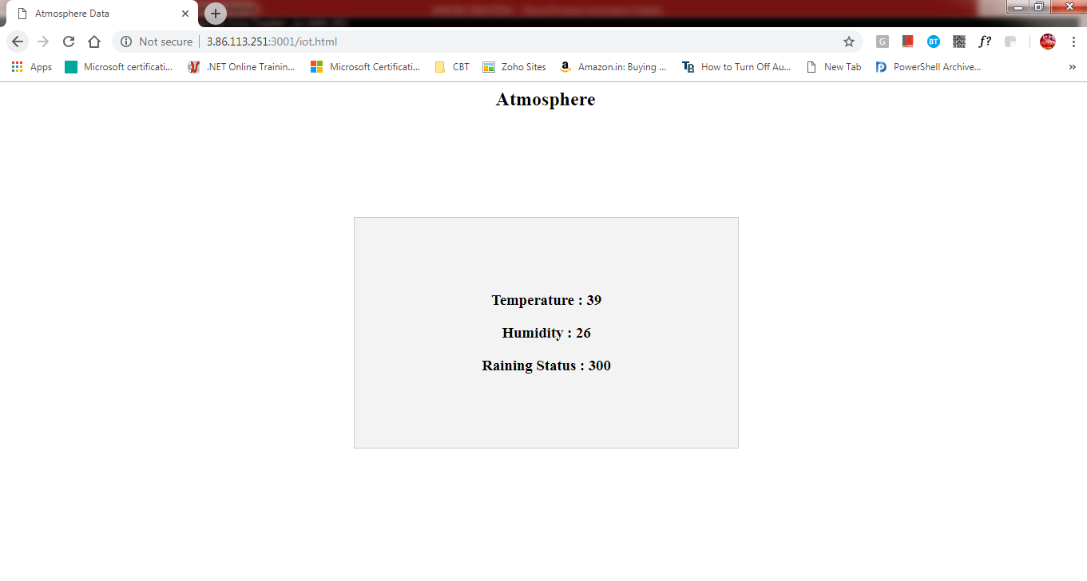

**6.2 IoT Web Page Code**

**Html code for IOT web page**

<html>

<head>

<title>

Atmosphere Data

</title>

<style>

body {

text-align:center;

}

.sensor{

background-color: black;

padding: 20px;

font-size: 35px;

color: white;

margin: 10px;

padding: 10px;

}

table, th, td {

border: 2px solid black;

border-collapse: collapse;

padding: 20px;

margin: 20px;

margin-left:auto;

margin-right:auto;

}

</style>

</head>

<body onload="updateValues()">

<div class="sensor">

<h2 style=" text-align: center;">Atmosphere</h2>

</div>

<table style="width:50%" bgcolor="gainsboro" align="center">

<tr>

<th> <h3 id="temperature">Temperature : </h3> </th>

</tr>

<tr>

<th> <h3 id="humidity">Humidity : </h3> </th>

</tr>

</table>

<script>

function updateValues() {

setInterval(function() {

getData();

},4000);

}

function getData() {

var xhttp = new XMLHttpRequest();

xhttp.onreadystatechange=function() {

if (this.readyState == 4 && this.status == 200) {

let response=JSON.parse(this.response);

document.getElementById("temperature").innerHTML = "Temperature : " + response.temperature;

document.getElementById("humidity").innerHTML = "Humidity : " + response.humidity;

}

};

xhttp.open("GET", "/api/getdata", true);

xhttp.send();

}

function putData(temp,humd){

var xhttp = new XMLHttpRequest();

xhttp.onreadystatechange=function() {

};

xhttp.open("POST", "/api/putdata", true);

xhttp.setRequestHeader("Content-type", "application/json");

xhttp.send(JSON.stringify({temperature:temp,humidity:humd}));

}

</script>

</body>

</html>

**6.2.1 IOT INTRODUCTION**:

IOT means Internet Of Things, the main aim of our project AWS Cloud and Network Security is to retrieve the data of cloud from anywhere at any time, if we have Internet Connection. In this project we are using sensors for getting information about temperature, humidity, rainfall at a particular location.

In this process, we have used different types of sensors they are

* For temperature and humidity information we are using DHT11 sensor.This is connected with Nodemcu.

# ***DHT11 temperature and Humidity sensor***

DHT11 sensor is used for measuring both humidity and temperature values.It can measure relative humidity in percentage (20 to 90% RH) and temperature in degree Celsius in the range of 0 to 50°C.It has 3 pins. They are:

1. VCC

2. DATA OUT

3. GND



# *Nodemcu:*

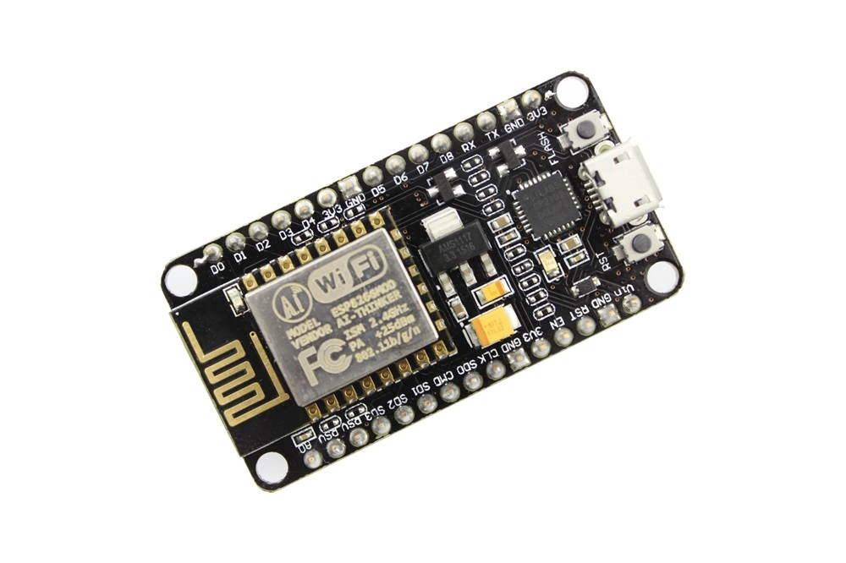

NodeMCU Dev Kit/board consist of ESP8266 wifi enabled chip. The **ESP8266** is a low-cost [Wi-Fi](https://en.wikipedia.org/wiki/Wi-Fi) chip developed by Espressif Systems with TCP/IP protocol. NodeMCU Dev Kit has **Arduino like** Analog (i.e. A0) and Digital (D0-D8) pins on its board.It supports serial communication protocols i.e. UART, SPI, I2C etc. Using such serial protocols we can connect it with serial devices like I2C enabled LCD display, Magnetometer HMC5883, MPU-6050 Gyro meter + Accelerometer, RTC chips, GPS modules, touch screen displays, SD cards etc.

# *DHT11 SENSOR CONNECTION WITH NODEMCU:*

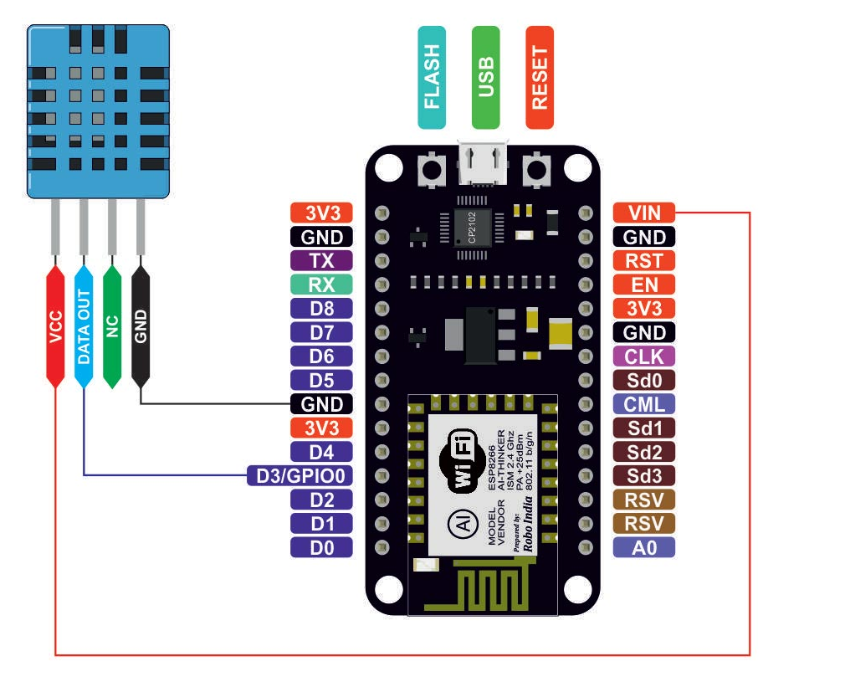

***Connection Of Nodemcu With Dht11 Sensor:***

**Pin 1** of the DHT11 goes into **+3v** of the NodeMCU.

**Pin 2** of the DHT11 goes into Digital Pin **D3** of the NodeMCU.

**Pin 3** of the DHT11 goes into Ground Pin (**GND**) of the NodeMCU.

***Installation of libraries:***

You need to install the **DHTLib** library. It has all the functions needed to get the humidity and temperature readings from the sensor. It’s easy to install.

Open up the**Arduino IDE,**then go to **Sketch** > **Include Library** > **Manage Libraries** > **Search DHTLib**

After it’s installed, upload this program to the NodeMCU and check output in the serial monitor.

* After connecting the devices the code is written and send to the cloud through MQTT protocol.
* There the code is uploaded into aurdino and it shows live data of temperature and humidity of a particular location for every 5 minutes.

***MQTT PROTOCOL:***

MQTT means Message Queuing Telemetry Transport. It is small size, light weight, low power usage, minimized data packets and ease of implementation .it is used for “machine-to-machine” connection.

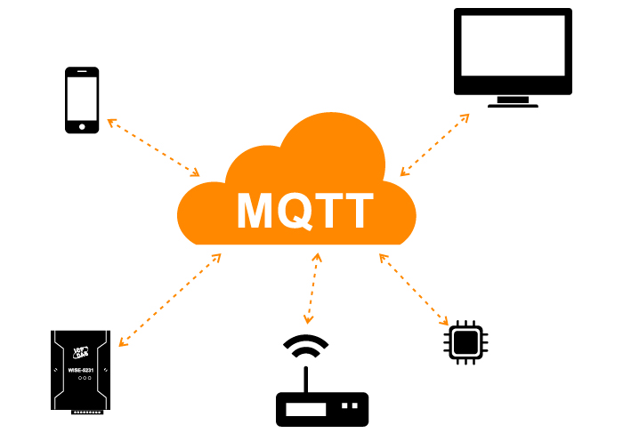.

# Features:

MQTT has unique features you can hardly find in other protocols, like:

* It’s a lightweight protocol. So, it’s easy to implement in software and fast in data transmission.
* It’s based on a messaging technique.
* Minimized data packets. Hence, low network usage.
* Low power usage. As a result, it saves the connected device’s battery.

***Working:***

 MQTT is based on clients and a server. The server is the one who is responsible for handling the client’s requests of receiving or sending data between each other. MQTT server is called a broker and the clients are simply the connected devices.

* When a device (a client) wants to send data to the broker, we call this operation a “publish”.
* When a device (a client) wants to receive data from the broker, we call this operation a “subscribe”.
* Publish, is the process a device does to send its message to the broker.
* Subscribe, where a device does to retrieve a message from the broker.

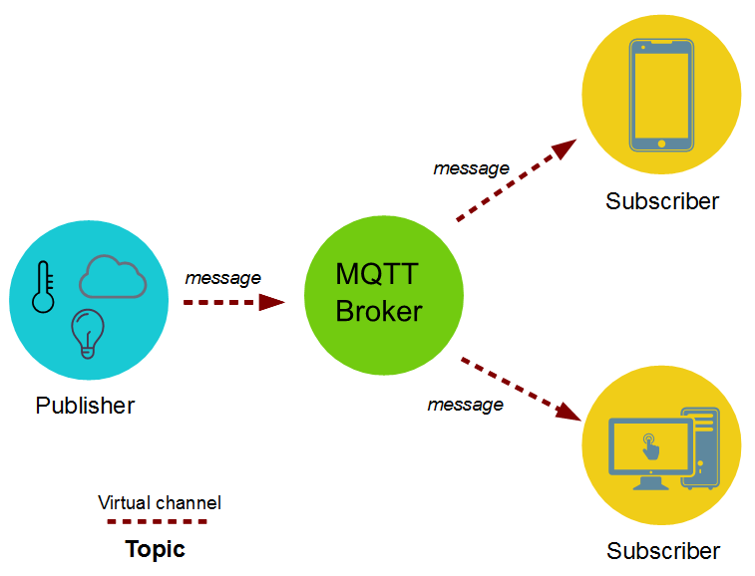

***Sending sensor data to client through MQTT protocol:***

The data such as temperature and humidity values from publisher is send to the **mqtt broker**. The broker role here is to take the message “temperature value” and deliver through a message to the subscriber phone or application.

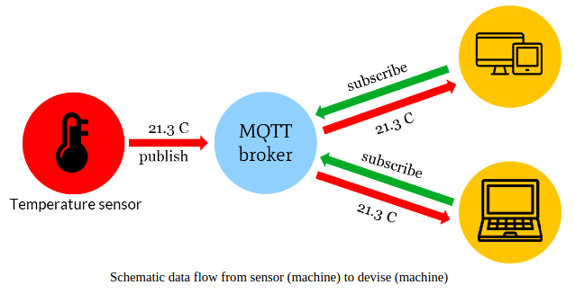

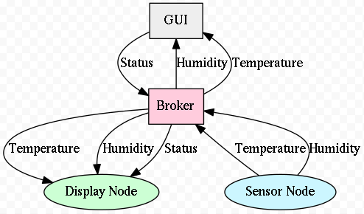

### 6.2.2 IoT ardunio code

/*

Temperature and Humidity Program

*/

#include <ESP8266WiFi.h>

#include <ESP8266WiFiGeneric.h>

#include <WiFiUdp.h>

#include <ESP8266WiFiType.h>

#include <WiFiClient.h>

#include <WiFiServerSecureAxTLS.h>

#include <BearSSLHelpers.h>

#include <ESP8266WiFiAP.h>

#include <ESP8266WiFiMulti.h>

#include <WiFiServerSecureBearSSL.h>

#include <WiFiClientSecureAxTLS.h>

#include <WiFiClientSecureBearSSL.h>

#include <WiFiClientSecure.h>

#include <ESP8266WiFiScan.h>

#include <CertStoreBearSSL.h>

#include <ESP8266WiFiSTA.h>

#include <WiFiServer.h>

#include <WiFiServerSecure.h>

#include <PubSubClient.h>

#include <dht.h>

int rainSensor = A0;

int rainReadValue;

const char* ssid = "Meraki";

const char* password = "193183183";

const char* mqttServer = "18.232.46.180";

const int mqttPort = 1883;

const char* PUB_TOPIC = "dht-resp";

WiFiClient espClient;

PubSubClient mqttclient(espClient);

// INDICATION LED

int wifiLed = 16;

int mqttLed = 5;

#define CLIENT_ID "ESP_Temp_Hum"

const int dhtPin = 4;

dht dht_var;

float temperature;

float humidity;

char payload[100];

void wifisetup()

{

WiFi.begin(ssid,password); // Initializing the wifi

while (WiFi.status()!=WL_CONNECTED)

{

digitalWrite(wifiLed,1);

delay(1000); // waiting for some time

Serial.println("connecting to the WiFi..");

digitalWrite(wifiLed,0);

}

Serial.println("Wifi connected");

digitalWrite(wifiLed,1);

}

void mqttconnect()

{

mqttclient.setServer(mqttServer, mqttPort);

while (!mqttclient.connected())

{

digitalWrite(mqttLed,1);

delay(1000);

if(mqttclient.connect(CLIENT_ID))

{

Serial.println("MQTT Connected");

digitalWrite(mqttLed,1);

}

else

{

Serial.println("Trying to connect to MQTT Broker");

digitalWrite(mqttLed,0);

delay(2000);

}

}

}

void sendData()

{

if (mqttclient.connect(CLIENT_ID))

{

Serial.println("sending message");

mqttclient.publish(PUB_TOPIC, payload);

}

}

void setup()

{

pinMode(wifiLed,OUTPUT);

pinMode(mqttLed,OUTPUT);

pinMode(dhtPin,INPUT);

Serial.begin(115200); // starting the serial communication.

wifisetup();

mqttconnect();

}

void loop() {

mqttclient.loop();

if (!mqttclient.connected())

{

mqttconnect();

}

dht_var.read11(dhtPin);

temperature = dht_var.temperature;

humidity = dht_var.humidity;

String temp = String(temperature);

String hum = String(humidity);

rainReadValue = analogRead(rainSensor);

rainReadValue = constrain(rainReadValue,150,440);

rainReadValue = map(rainReadValue,150,440,1023,0);

String rainRead_Val = String(rainReadValue);

String jsonMsg = "{";

jsonMsg += "\"ID\":\"Temp_Hum\",";jsonMsg += "\"temperature\":";

jsonMsg += temperature; jsonMsg += ",";jsonMsg += "\"humidity\":"; jsonMsg += humidity;

jsonMsg += ",\"rainVal\":";

jsonMsg += rainRead_Val;jsonMsg += "}";

jsonMsg.toCharArray(payload,100);

sendData();

jsonMsg = " ";

jsonMsg.toCharArray(payload,100);

delay(6000);

}

**6.2.3 MQTT SETUP**

Configure & Launch the EC2 Instance

First of all you need to have an AWS account. If you don’t have one, you can create a new account on AWS ([https://aws.amazon.com](https://aws.amazon.com/)) and get one year computing, storage and serveral other services for free using the so called “Free Tier”.

1. Logon to the AWS Console and then select EC2 in services Section

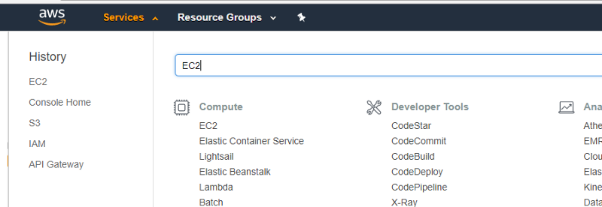

Select EC2

2. Select the preferred AWS region and then launch a new instance

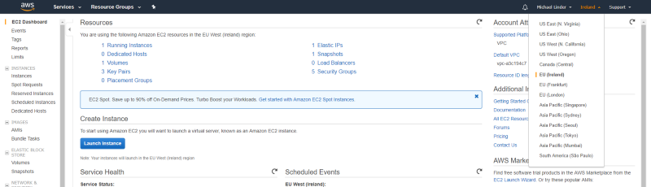

Select AWS region and launch

3. Select Ubuntu Server



4. Select an instance type

In order to use the free tier contingent, it’s recommended to use t2.micro for testing purposes.

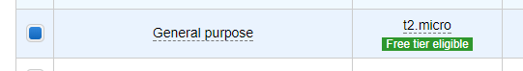

t2.micro selection

6. Configure security group

In this example following ports will be used:

Step 1: Install Mosquitto

Log into the AWS Ubuntu 16/18 machine.

$ sudo apt-get update

Install

$ sudo apt-get install mosquitto mosquitto-clients

The command above installs both the mosquitto broker and the  
publish / subscribe clients. The mosquitto broker is now installed and active. You can listen to declare any channel to subscribe and publish to test it

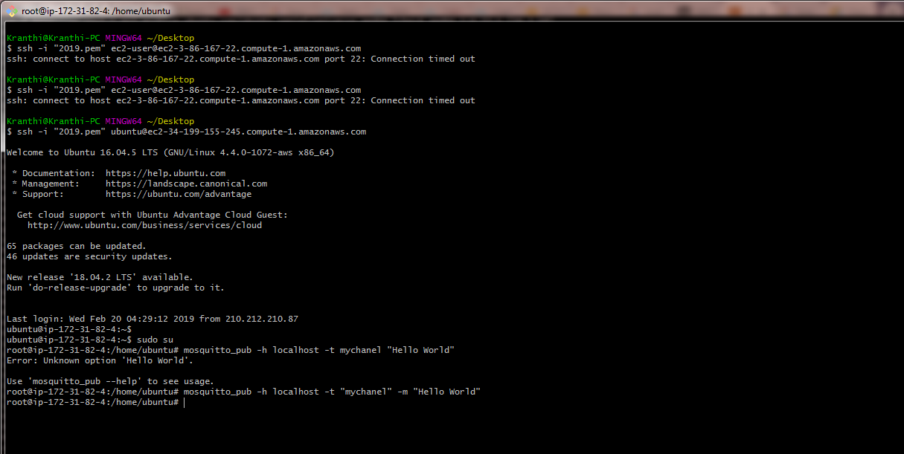

open the duplicate session for this Ubuntu, type the same command for publish

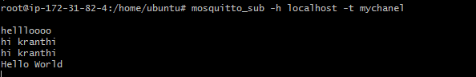

**6.3 Database Creation**

This below code is the main source file Index.js to perform whole server operations. This index.js server calls the database table information and acts as an API to connect the web page and database.

We need to install npm, MySQL and express js to run this node js file.

**Npm (node packet manager):** **NPM** basically **is** the package manager for node. It helps with installing various packages and resolving their various dependencies. It greatly helps with your Node development.

**How it is helpful in our project**: Using this npm, we have specified all our project’s dependencies inside the package.json file, when any time we want to run our web server we can just **run npm install** and all the dependencies installed. Manually adding these files kills time and messy.

**MySQL**: AWS support MySQL to store the values into a database we used MySQL. We can add, delete, retrieve, and modify the values on a database.

**Express Js**: It is a web application framework for nodejs and provides simple API’s to build websites, web-apps, and backend. It is flexible as there are numerous modules available on **npm**, which can be directly plugged into Express.

The database created here is atmospheredb, This atmospheredb contains atmosphere table with field names temperature, humidity and created time.

**6.3.1 Setting Database path:**

**Mysql DB Creation**

#!/bin/bash

# this script is not compatible with dash shell; hence the above shebang is mandatory

# ------------------------------------------------------------------------- #

# This script shall create database and required users.

#INSTRUCTIONS:

#1.This script executes as mysql root

#2.change dbname, pwd values respectively

#3.Depending on VM & mysql installation edit the dbpath variable

#Scripts to be executed in the following order:

# 1.db_scripts_p1.sh script

# 2. create tables, foreign keys etc..

# 3.db_scripts_p2.sh script

# Created date : 26-Jan-18

# Initial Author : Sai

# ------------------------------------------------------------------------- #

# ---Variables to be modified at runtime. User permissions-------------------------------- #

**dbname=atmospheredb**

**owner_user='root'**

**owner_pwd='passw0rd'**

**root_pwd='passw0rd'**

**dbpath="mysql -u root -e "**

#dbpath="$mysql --host=127.0.0.1 -u root -p$root_pwd -e "

# ------------------------------------------------------------------------- #

# Here $dbname will call node js program, there given database name , it will be recalled and stored in $dbname# ------------------------------------------------------------------------- #

# creating databse steps

**$dbpath"CREATE DATABASE $dbname ;"**

# ------------------------------------------------------------------------- #

# creating OWNER user / grants steps

**$dbpath"CREATE USER '$owner_user' IDENTIFIED BY '$owner_pwd' ;"**

**$dbpath"GRANT ALL ON $dbname.* TO '$owner_user' WITH GRANT OPTION;"**

#$dbpath "ALTER USER '$owner_user'@'localhost' IDENTIFIED WITH mysql_native_password BY '$owner_pwd';"

**Table Values**

Resources to create db:

User.sql=>contains the sql table creation and data to be inserted into created table

create table atmospheretable(

id int auto_increment,

temperature smallint,

humidity smallint,

created_time datetime,

PRIMARY KEY (id)

);

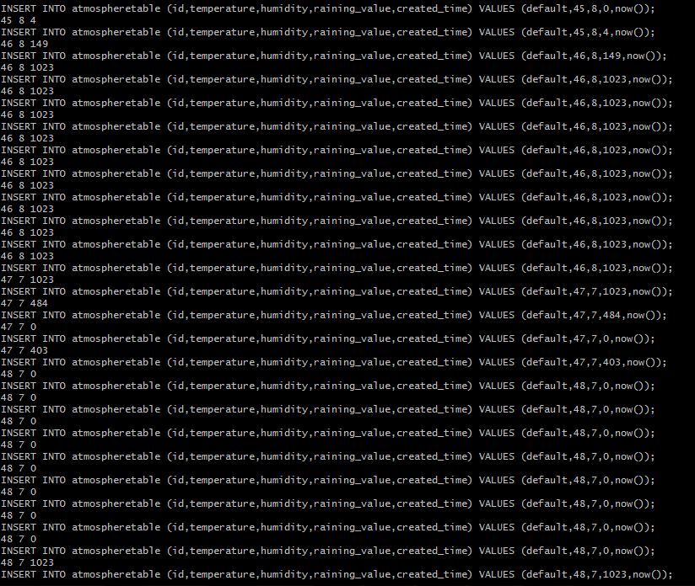

**6.3.2 Downloading and Installations:**

Initialsetupdeploy.sh (Script file for installing node js npm and creating wbsitedeploy directory)

#!/bin/bash

curl -sL https://rpm.nodesource.com/setup_10.x | sudo -E bash -;

**yum install nodejs --enablerepo=nodesource -y;**

**npm install npm -y;**

**mkdir wbsite-deploy;**

**cd wbsite-deploy;**

**npm init -y;**

**npm install express --save;**

**npm install mysql --save;**

**6.3.3 Connecting database to website:**

**node index.js (Main java script file for )**

const express = require('express'); // express driver installation

const app = express();

const mysql = require('mysql'); //mysql driver installation

const dbcon = mysql.createConnection({

'host':'localhost', //creating a connection to a database

'port':3306,

'user':'root',

'database':'atmospheredb'

});

app.use(express.json());

app.use(express.static('public'));

dbcon.connect(function(err,res){

if(err) {

console.log("err",err);

}else{

console.log("success");

}

});

app.get('/api/getdata', function(req,res){//

getData(req, res);

});

app.post('/api/putdata', function(req,res){

putData(req.body, res);

});

function getData(req,res){

dbcon.query('select * from atmospheretable order by created_time desc limit 1;',function(error,result){

if(error)

{

res.send(error);

}else

{

res.send(result.length?result[0]:result);

}

});

}

//insert into atmosphere tables the values

function putData(req,res){

dbcon.query('insert into atmospheretable (temperature,humidity,created_time) values (?,?,now()) ;',[req.temperature,req.humidity],function(error,result){

if(error) {

res.send(error);

}else {

res.send(result.length?result[0]:result);

}

});

}

app.listen(3001, () => console.log('Server running on port 3001')); //acknowledgement to the user that server is running.

**6.4 Python MQTT setup Code**

import ast

import paho.mqtt.client as mqtt

import ConfigParser

import simplejson as json

import logging

import datetime

import pymysql

LOG_FILENAME = 'FeedbackServer.log'

logging.basicConfig(filename=LOG_FILENAME,level=logging.DEBUG,format='%(asctime)s, %(levelname)s, %(message)s', datefmt='%Y-%m-%d %H:%M:%S')

class MQtt:

def __init__(self,host,port,subTopic,cur,db,timealive=60):

self.host = host

self.port = port

self.timealive = timealive

self.payload = None

self.subTopic = subTopic

self.pubTopic = "feedback-serv"

self.cur = cur

self.db = db

def __on_connect(self,client, userdata, flags, rc):

try:

print "Connected with result code "+str(rc)

if self.subTopic!=None:

(result,mid)= client.subscribe(self.subTopic)

print result

except Exception as e:

logging.error("The on_connect error %s,%s"%(e,type(e)))

def __on_message(self,client, userdata, msg):

try:

data = msg.payload

message = ast.literal_eval(data)

temperature = int(message["temperature"])

humidity = int(message["humidity"])

print temperature,humidity

insertStatement = "INSERT INTO atmospheretable (id,temperature,humidity,created_time) VALUES (default,"+str(temperature)+","+str(humidity)+",now());"

print insertStatement

try:

self.cur.execute(insertStatement)

except Exception as e:

print e

except Exception as e:

print e

logging.error("The on_message error %s,%s"%(e,type(e)))

def connect(self):

try:

self.mqttc = mqtt.Client()

self.mqttc.on_connect = self.__on_connect

self.mqttc.on_message = self.__on_message

self.mqttc.connect(self.host,self.port,self.timealive)

if self.subTopic != None:

print "Hu"

self.mqttc.loop_start()

self.mqttc.loop_forever()

except Exception as e:

logging.error("The connect error %s,%s"%(e,type(e)))

def send(self,message):

try:

(result,mid) = self.mqttc.publish(self.pubTopic,message,2)

return result

except Exception as e:

print e

logging.error("The send error %s,%s"%(e,type(e)))

if __name__ == '__main__':

# Mysql details

host = "localhost"

database = "atmospheredb"

table = "atmospheretable"

db = pymysql.connect(host="localhost",db="atmospheredb",autocommit=True)

cur = db.cursor()

# MQTT DETIALS

host = "18.232.46.180"

port = 1883

subTopic = "dht-resp"

mq = MQtt(host,port,subTopic,cur,db)

mq.connect()

**6.5 Storing Atmosphere Details into Database table**

import pymysql

import time

host = "localhost"

db = pymysql.connect(host="localhost",db="atmospheredb",autocommit=True)

cur = db.cursor()

temperature = 64

humidity = 36

print temperature,humidity

insertStatement = "INSERT INTO atmospheretable (id,temperature,humidity,created_time) VALUES (default,"+str(temperature)+","+str(humidity)+",now());"

print insertStatement

try:

cur.execute(insertStatement)

time.sleep(10)

except Exception as e:

print e

sqlQuery = "select * from atmospheretable;"

#Fetch all the rows - for the SQL Query

cur.execute(sqlQuery)

rows = cur.fetchall()

for row in rows:

print(row)

**7 Amazon EC2:**

Amazon Elastic Compute Cloud (Amazon EC2) provides scalable computing capacity in the Amazon Web Services (AWS) cloud. Using Amazon EC2 eliminates your need to invest in hardware up front, so you can develop and deploy applications faster. You can use Amazon EC2 to launch as many or as few virtual servers as you need, configure security and networking, and manage storage. Amazon EC2 enables you to scale up or down to handle changes in requirements or spikes in popularity, reducing your need to forecast traffic.

**Features of Amazon EC2**

Amazon EC2 provides the following features:

* Virtual computing environments, known as *instances*
* Preconfigured templates for your instances, known as *Amazon Machine Images (AMIs)*, that package the bits you need for your server (including the operating system and additional software)
* Various configurations of CPU, memory, storage, and networking capacity for your instances, known as *instance types*
* Secure login information for your instances using *key pairs* , Storage volumes for temporary data that's deleted when you stop or terminate your instance, known as *instance store volumes*
* Persistent storage volumes for your data using Amazon Elastic Block Store (Amazon EBS), known as *Amazon EBS volumes*
* Multiple physical locations for your resources, such as instances and Amazon EBS volumes, known as *regions* and *Availability Zones*
* A firewall that enables you to specify the protocols, ports, and source IP ranges that can reach your instances using *security groups*
* Metadata, known as *tags*, that you can create and assign to your Amazon EC2 resources
* Virtual networks you can create that are logically isolated from the rest of the AWS cloud, and that you can optionally connect to your own network, known as *virtual private clouds* (VPCs)

**How to launch an EC2 instance on AWS:**

Now we need to deploy this web portal on our EC2 instance to make this portal available for multiple users who wants to make use of.

Creation of Instance in AWS Console:

Step 1: Choose the Instance option in AWS EC2.

Step 2: Launch Instance that was on the top right side of the screen displayed.

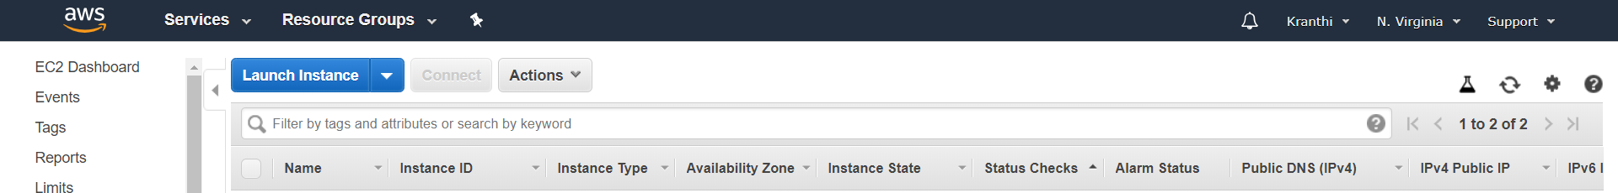

Step 3: Choose an Amazon Machine Image(AMI).We choose (**Amazon Linux AMI 2018.03.0 (HVM), SSD Volume Type** - ami-0080e4c5bc078760e) free tier to launch our web portal.

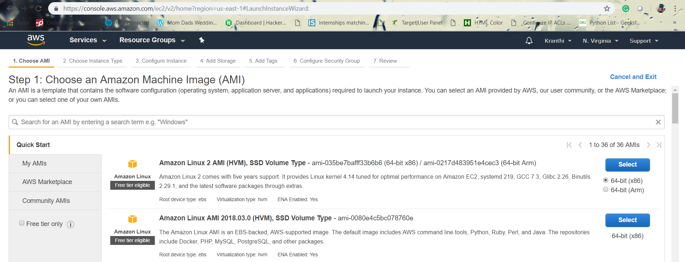

Step 4: Now choose an Instance type which fits to different use cases. Instances are Virtual Web servers that run our application. We choose (**:** t2.micro (Variable ECUs, 1 vCPUs, 2.5 GHz, Intel Xeon Family, 1 GiB memory, EBS only)) for general purpose.

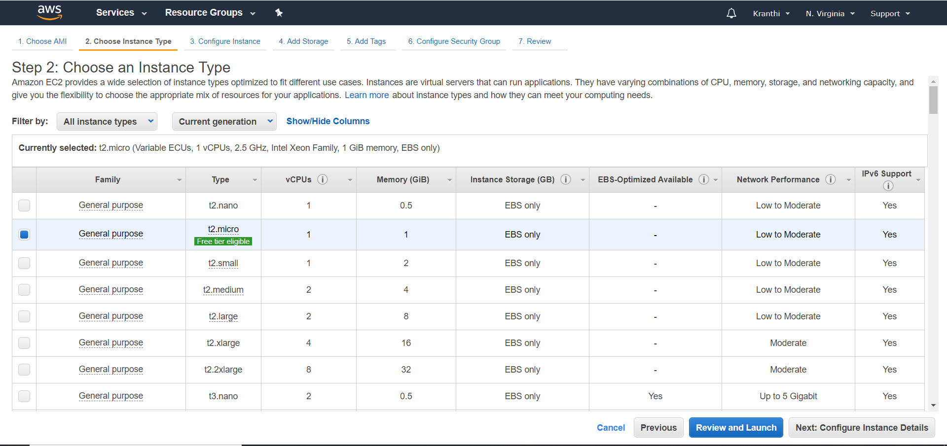

Step 5: Configure Instance details

Configure the instance to suit your requirements. You can launch multiple instances from the same AMI, request Spot instances to take advantage of the lower pricing, assign an access management role to the instance, and more.

Step 6: Add security groups

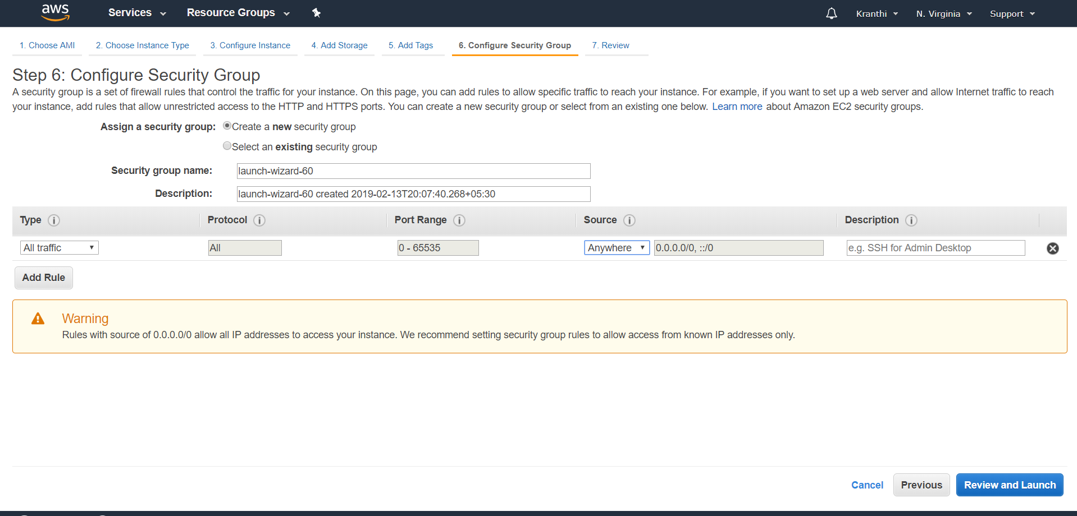

Step 7: On the **Review Instance Launch** page, choose **Launch**.

When prompted for a key pair, select **Choose an existing key pair**, then select the key pair that you created when getting set up.

Alternatively, you can create a new key pair. Select **Create a new key pair**, enter a name for the key pair, and then choose **Download Key Pair**.

This is the only chance to save the private key file, so be sure to download it. Save the private key file in a safe place. You'll need to provide the name of your key pair when launching an instance and the corresponding private key each time you connect to the instance.

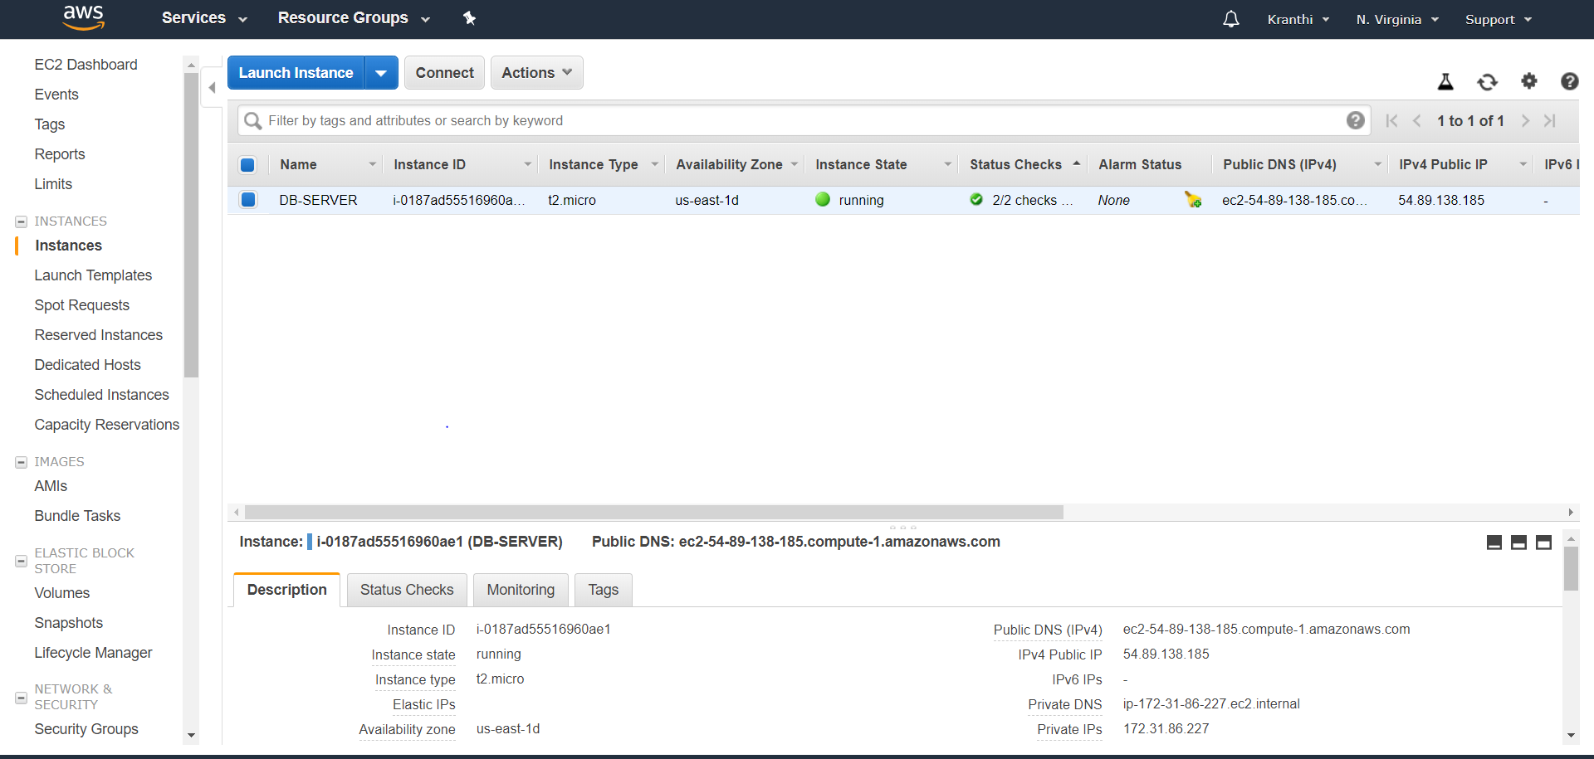

* Now launch the web portal on the created EC2 Instance. To deploy the web portal we need to have a little idea about LINUX.
* Install and run Gitbash, to manage ec2 instances.
* Install filezilla. To move our web code files from desktop to cloud EC2 instance.

**Execute the following commands on Gitbash console:**

**1.To connect EC2 instance remotely use the below command.**

**$ssh -i "2019.pem"** [**ec2-user@ec2-3-83-103-44.compute-1.amazonaws.com**](mailto:ec2-user@ec2-3-83-103-44.compute-1.amazonaws.com)

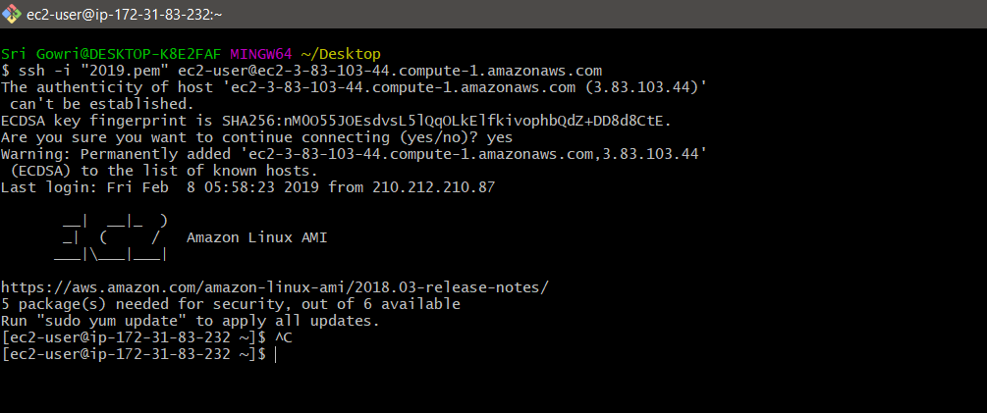

**7.1 Procedure for running web scripts on server:**

Sudo su //user permissions to access the EC2

Ls

Cd Resources/

ls

chmod 700 db_setup.sh

chmod 700 initialSetupwensiteDeploy.sh

yum install mysql-server

service mysqld start

./db_setup.sh

mysql -u root

mysql> show databases;

[root@ip-172-31-84-75 Resources]# **ls**

db_setup.sh initialSetupWensiteDeploy.sh User.sql

[root@ip-172-31-84-75 Resources]# **mysql atmospheredb <User.sql**

[root@ip-172-31-84-75 Resources]# **mv initialSetupWensiteDeploy.sh /home/ec2-user/**

[root@ip-172-31-84-75 Resources]# **ls**

db_setup.sh User.sql

[root@ip-172-31-84-75 Resources]# **cd ..**

[root@ip-172-31-84-75 ec2-user]# **ls**

as.pem initialSetupWensiteDeploy.sh Resources

[root@ip-172-31-84-75 ec2-user]# **./initialSetupWensiteDeploy.sh**

## Installing the NodeSource Node.js 10.x repo...

[root@ip-172-31-84-75 ec2-user]# **cd db**

[root@ip-172-31-84-75 db]# **ls**

index.js public

[root@ip-172-31-84-75 db]# **mv index.js /home/ec2-user/website-deploy/**

[root@ip-172-31-84-75 db]# **mv public /home/ec2-user/website-deploy/**

[root@ip-172-31-84-75 db]# **ls**

[root@ip-172-31-84-75 db]# **cd ..**

[root@ip-172-31-84-75 db]# **npm install express –save**

[root@ip-172-31-84-75 db]# **npm install mysql --save**

[root@ip-172-31-84-75 ec2-user]# **cd wbsite-deploy/**

[root@ip-172-31-84-75 wbsite-deploy]# **ls**

index.js node_modules package.json package-lock.json public

[root@ip-172-31-84-75 wbsite-deploy]# **node index.js**

**8. ELASTIC LOAD BALANCER**

Elastic Load Balancing automatically distributes incoming application traffic across multiple targets, such as Amazon EC2 instances, containers, IP addresses, and Lambda functions. It can handle the varying load of your application traffic in a single Availability Zone or across multiple Availability Zones. Elastic Load Balancing offers three types of load balancers that all feature the high availability, automatic scaling, and robust security necessary to make your applications fault tolerant.

These are classified into 3 types, they are Application Load Balancer, Network Load Balancer, Classic Load Balancer. In our project we have used Application Load Balancer, this operates at the request level(layer 7), routing traffic to targets – EC2 instances, containers, etc. This provides advanced request routing targeted at delivery of modern application architectures. This simplifies and improves the security of our application ,by ensuring that the latest SSl/TLS ciphers and protocols are used at all times.

**High availability**

Elastic Load Balancing automatically distributes traffic across multiple targets – Amazon EC2 instances, containers and IP addresses – in a single Availability Zone or multiple Availability Zones.

**Health Checks:**

An Application Load Balancer routes traffic only to healthy targets. With an Application Load Balancer, you get improved insight into the health of your applications in two ways: (1) health check improvements that allow you to configure detailed error codes from 200-499. The health checks allow you to monitor the health of each of your services behind the load balancer; and (2) new metrics that give insight into traffic for each of the services running on an EC2 instance.

**How to add Load Balancer in AWS :**

Step 1: Login to the AWS Console.

Step 2: Select EC2 Instances, there you find Load Balancer.

Step 3: Choose Create Load Balancer that appeared on the screen below. 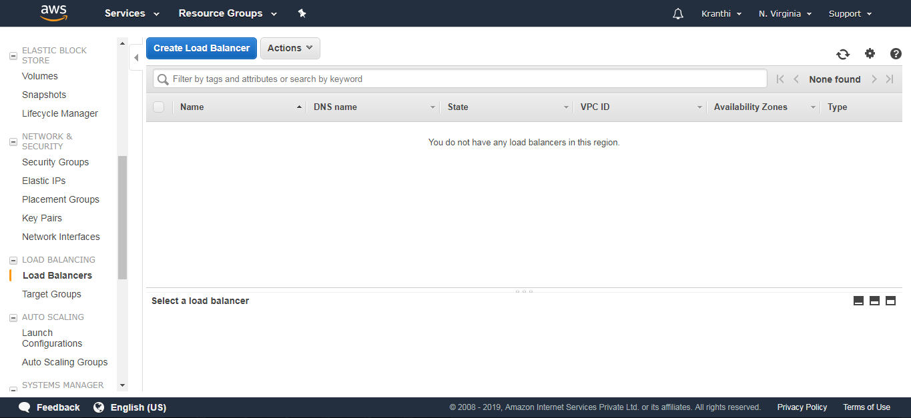

Step 4: Select Application Load Balancer and click on create.

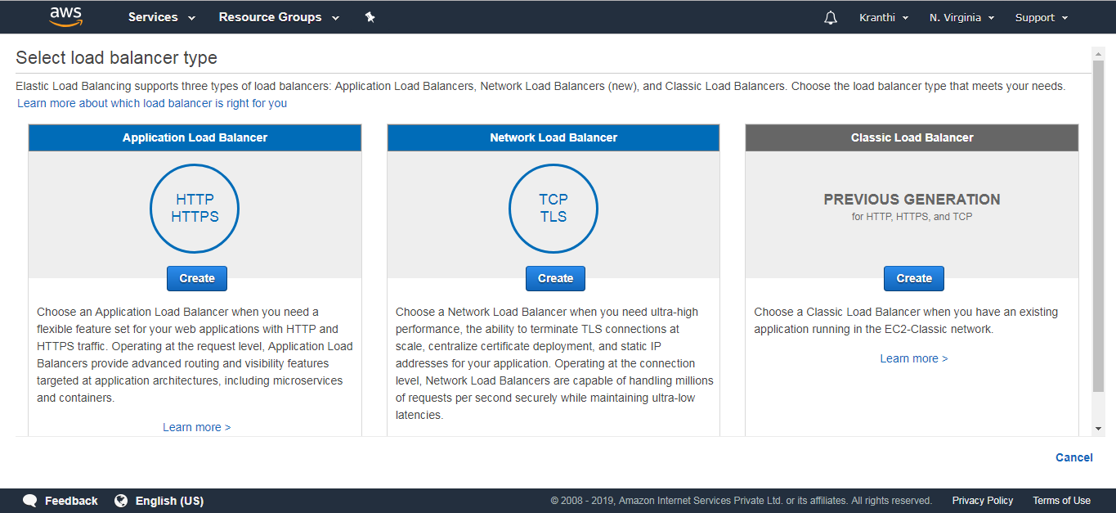

Step 5: Configure Load Balancer.

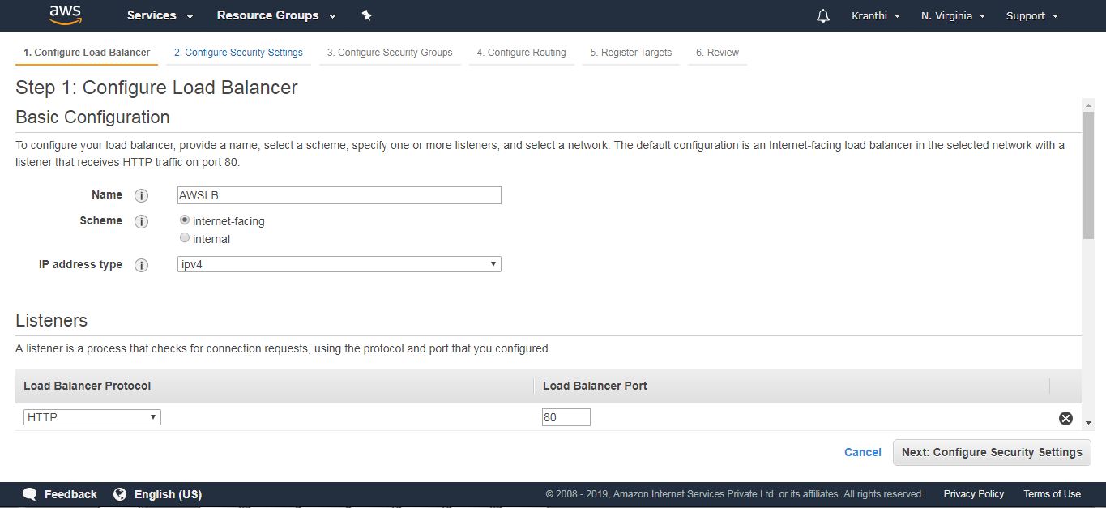

Add the availability Zones

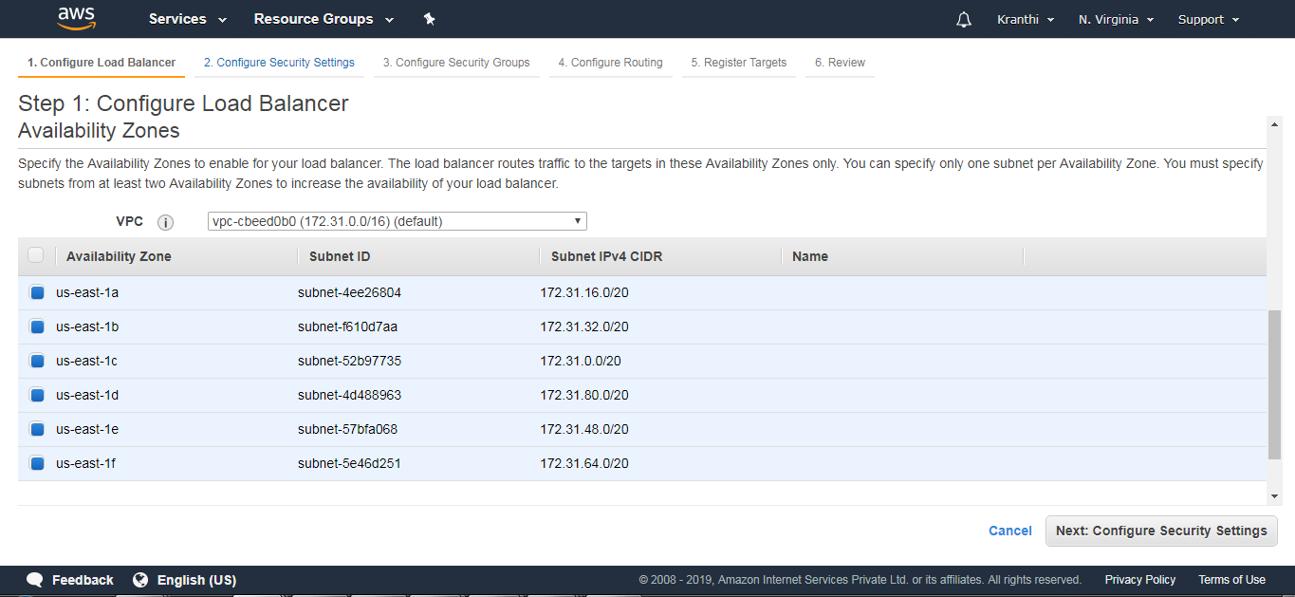

Step 6: Configure Security groups.

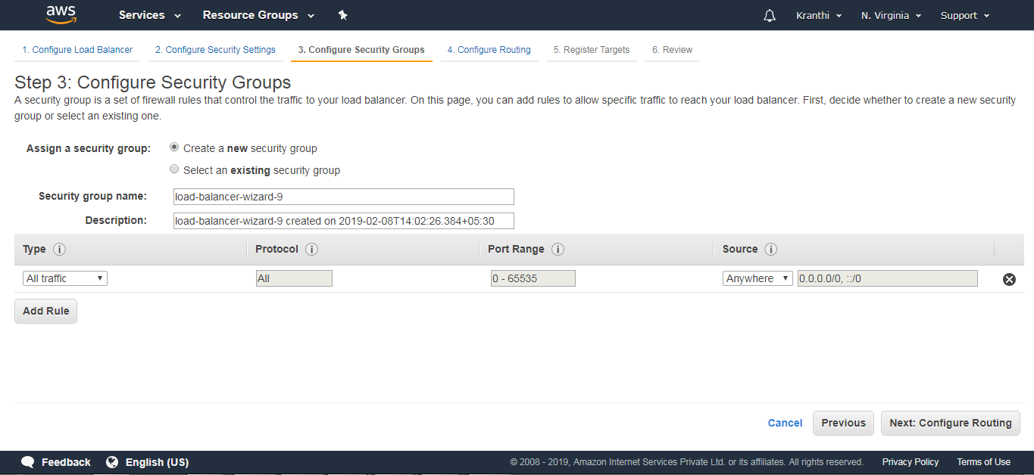

Step 7: Configure Routing

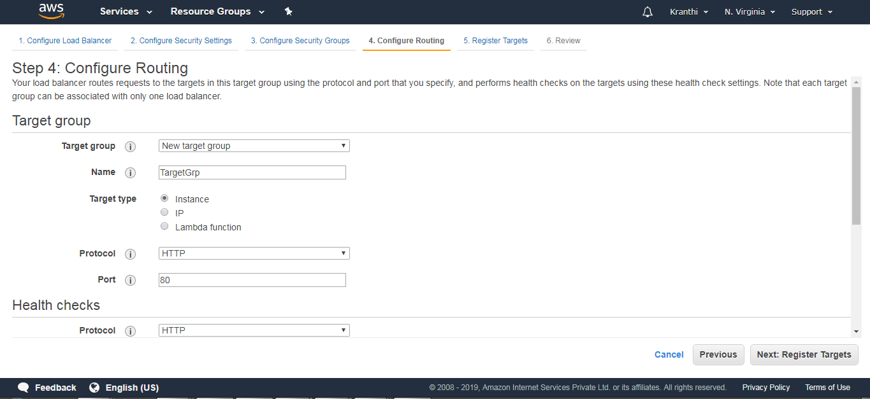

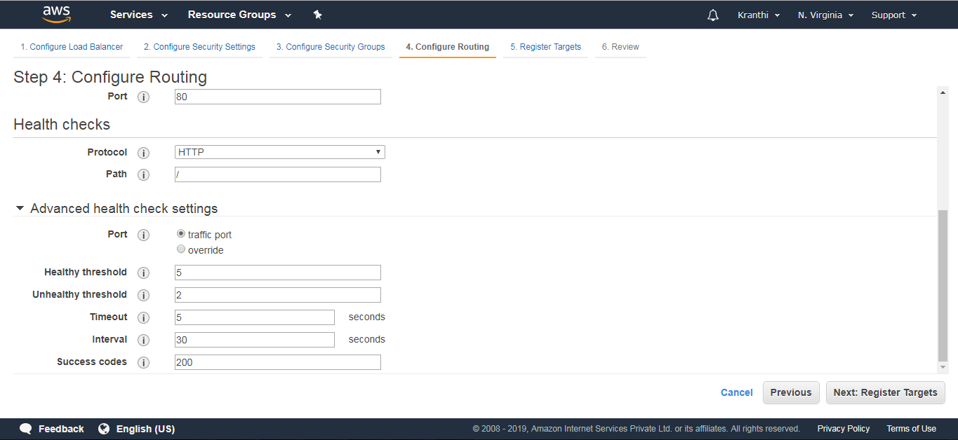

Step 8: Register Targets (nothing but EC2 instances that are created).

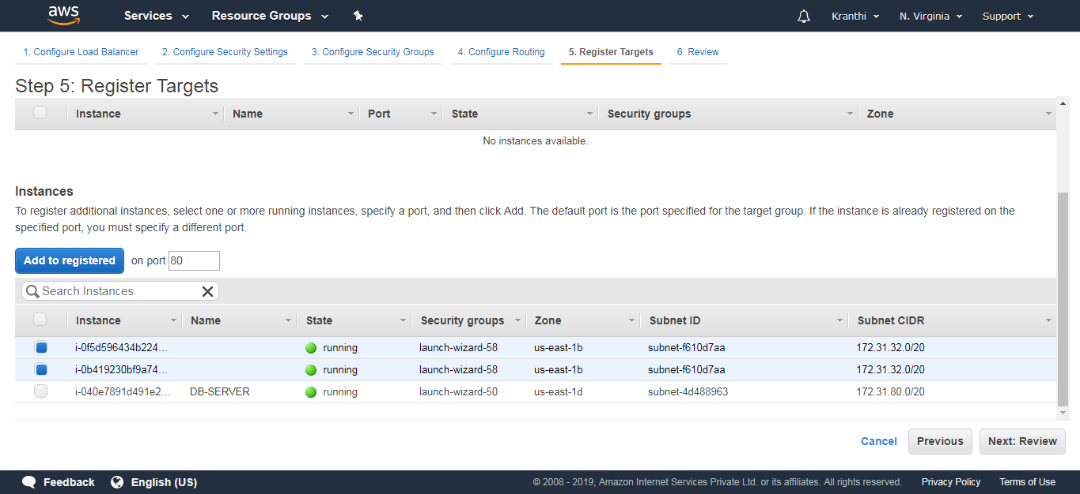

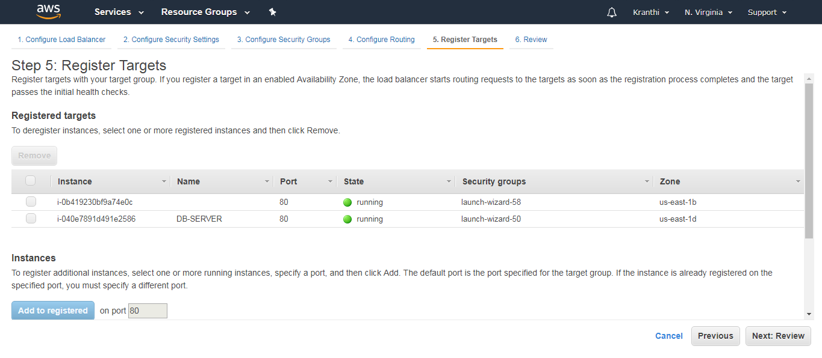

Review: View all the information of an Elastic Load Balancer.

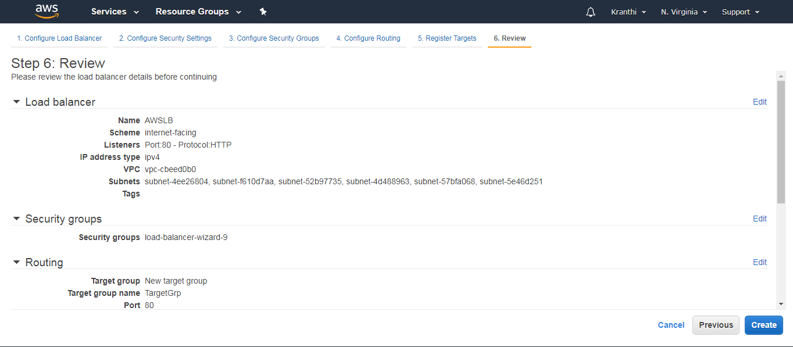

Step 9: We can now notice the notification that Load Balancer is created.

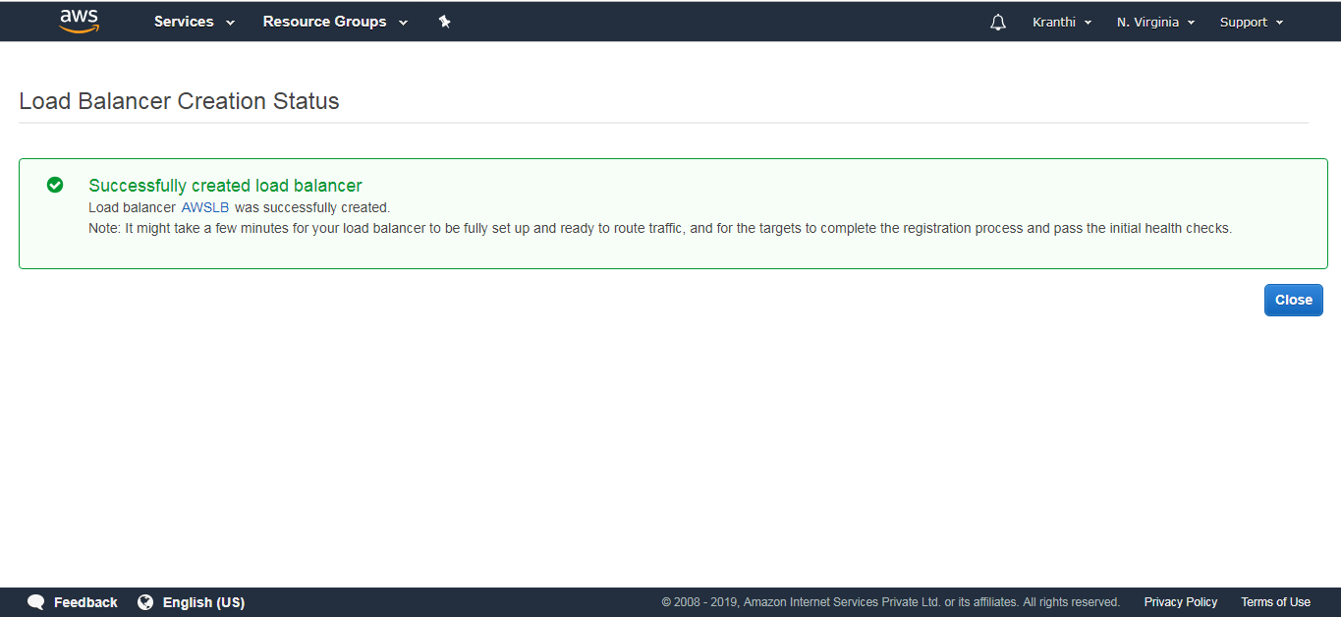

Check whether the web instances are healthy when added to a load balancer.

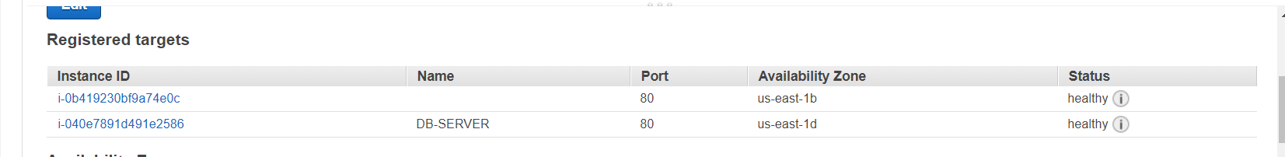

Step 10: This is the Load Balancer that we have created.

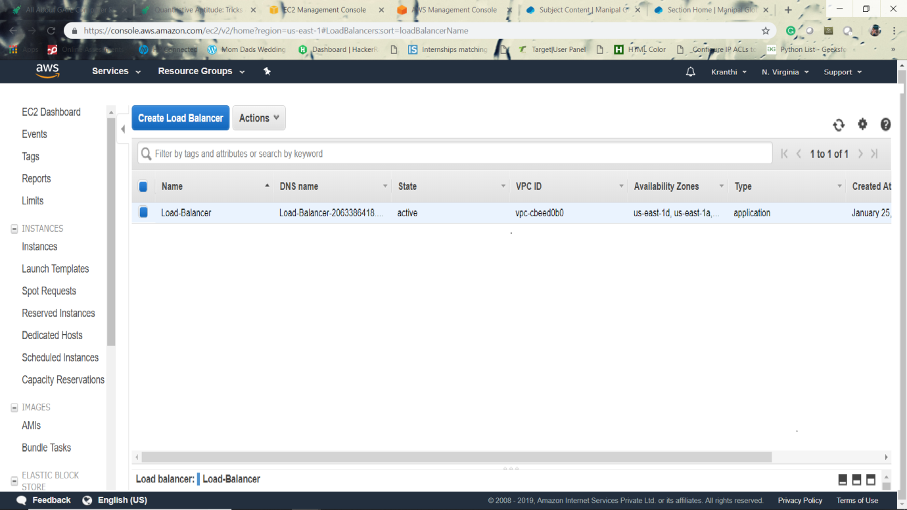

The web portal runs on a specified URL of Elastic Load Balancer

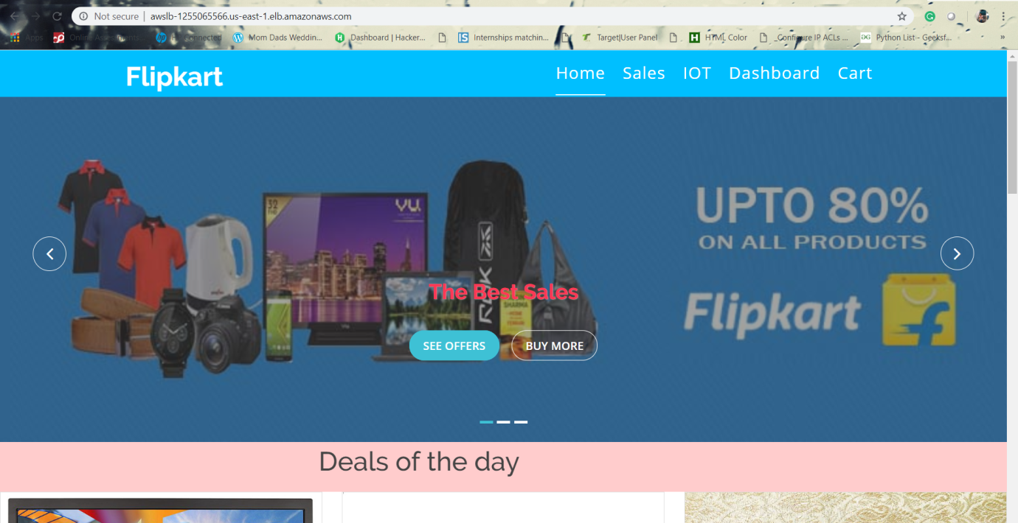

**9 AUTO SCALING:**

An *Auto Scaling group* contains a collection of Amazon EC2 instances that share similar characteristics and are treated as a logical grouping for the purposes of instance scaling and management. If you might want to increase the number of instances in that group to improve the performance of the application. Or, you can decrease the number of instances to reduce costs when demand is low. Use the Auto Scaling group to scale the number of instances automatically based on criteria that you specify. You could also maintain a fixed number of instances even if an instance becomes unhealthy. This automatic scaling and maintaining the number of instances in an Auto Scaling group is the core functionality of the Amazon EC2 Auto Scaling service.

There are two tasks to be followed for Auto-Scaling, they are

1. Create a launch template

2. Create Auto-Scaling group.

**Create a Launch Template**

**To create a launch template for an Auto Scaling group**

Step 1: Open the Amazon EC2 console.

Step 2: On the navigation bar, select a region. The Amazon EC2 Auto Scaling resources that you create are tied to the region you specify.

Step 3: On the navigation pane, choose **Instances**, **Launch Templates**.

Step 4: Choose **Create launch template**.

**Step 5: Create Auto Scaling group**.

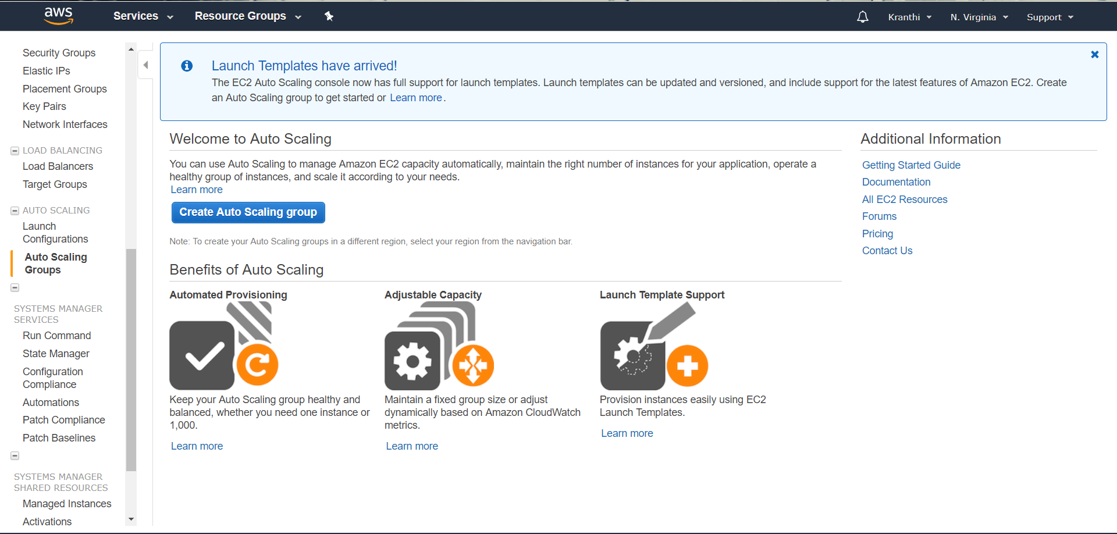

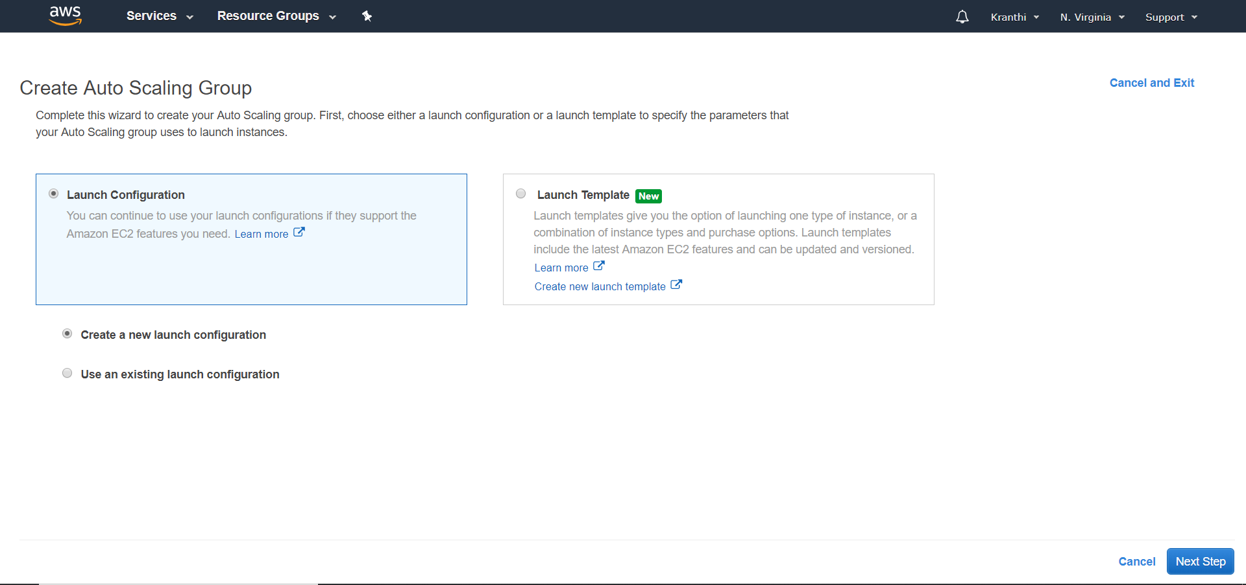An AMI is a template that contains the software configuration to launch the instances.

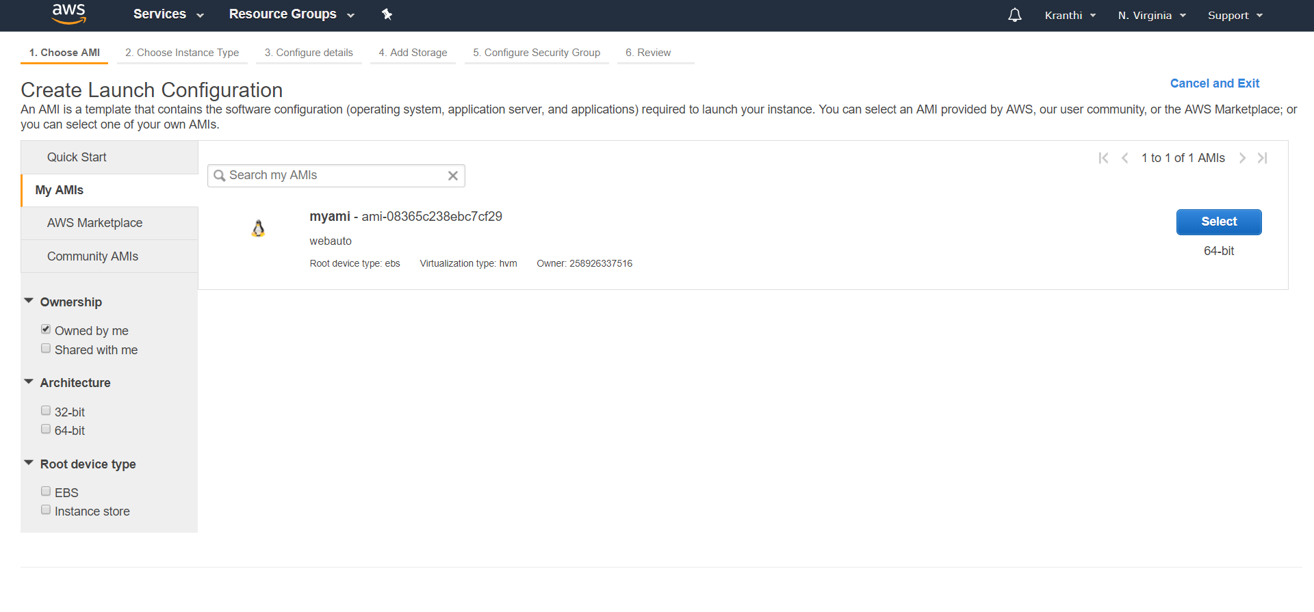

Configure the Launch configuration, set the name to display.

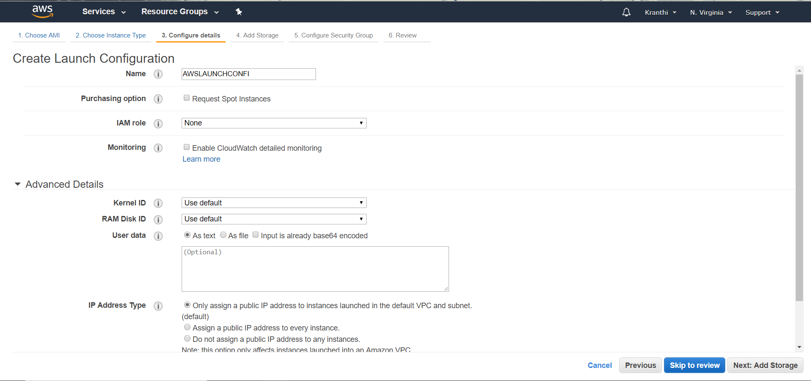

Storage settings to your instance.

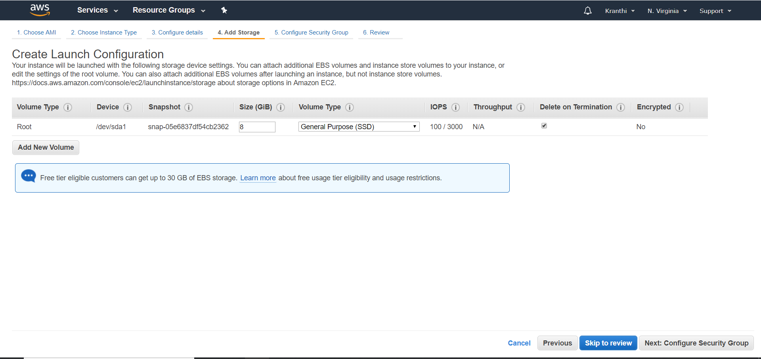

Configure security group and add own rules.

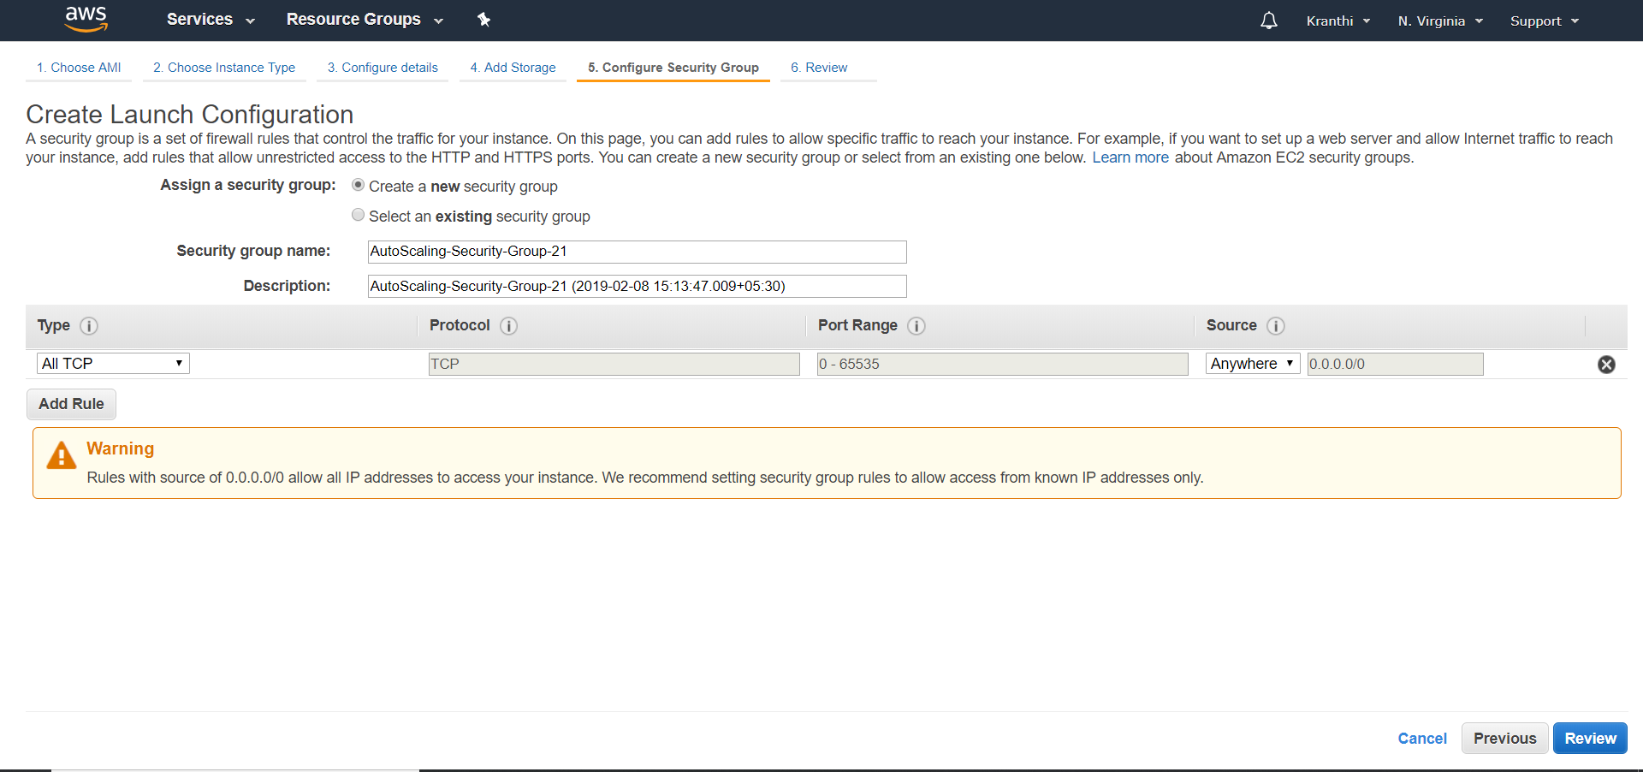

Review gives the total information about AMI.

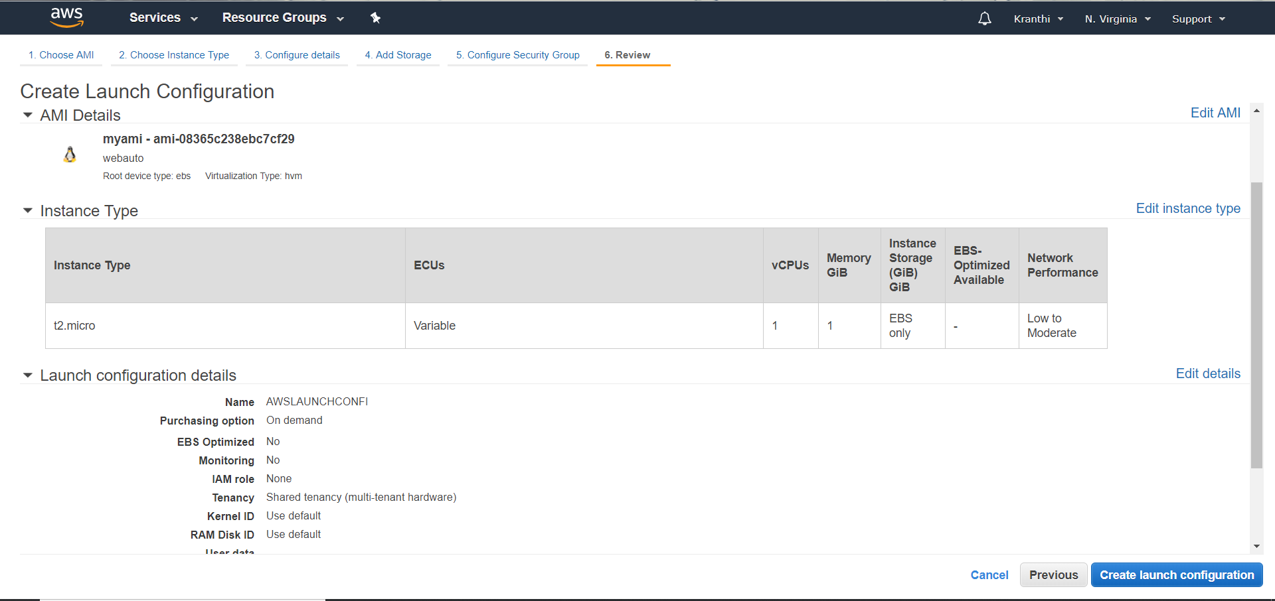

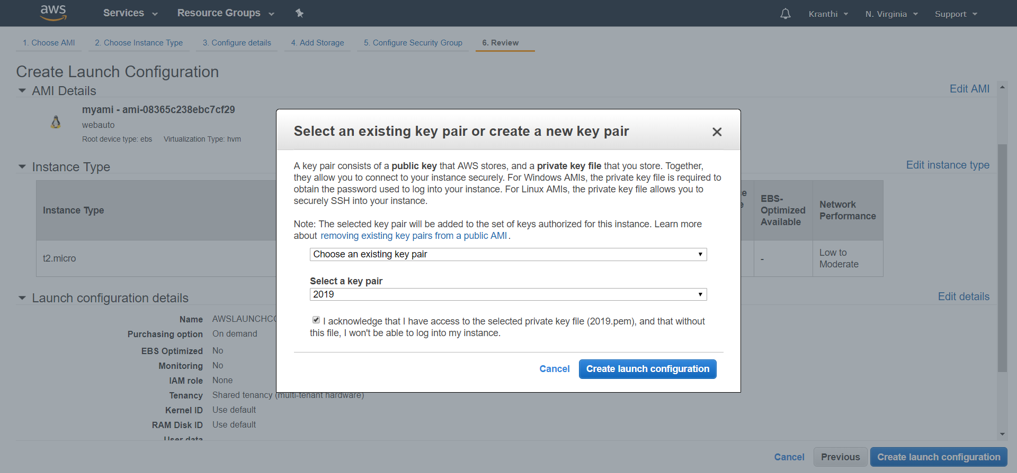

Create Auto-Scaling groups after the launch configurations.

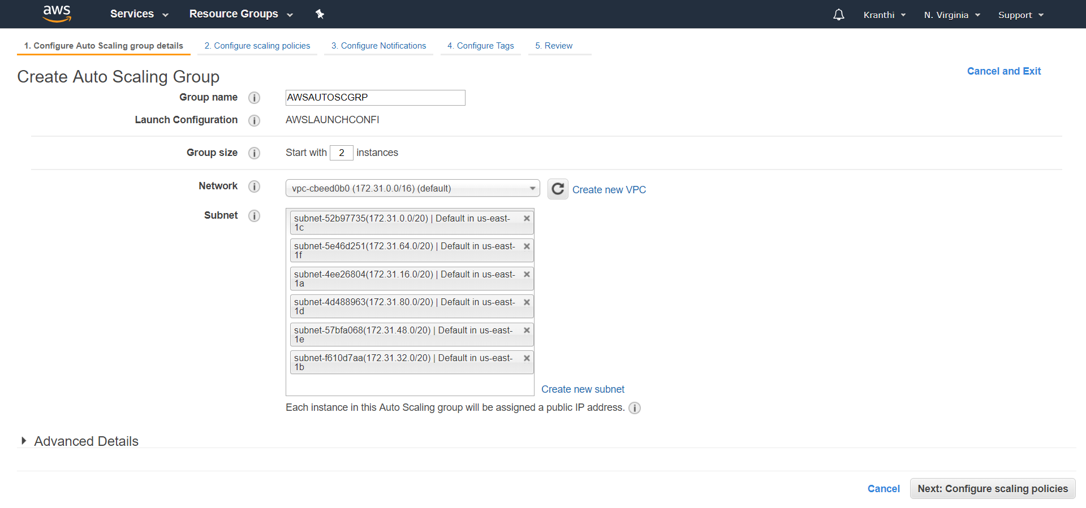

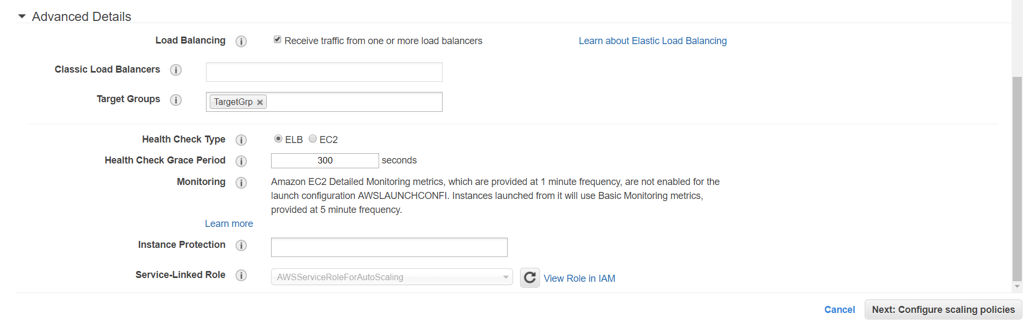

In this Auto-Scaling group, we need write how many instances we need to add when the avg-C.P.U percentages goes high or decrease.

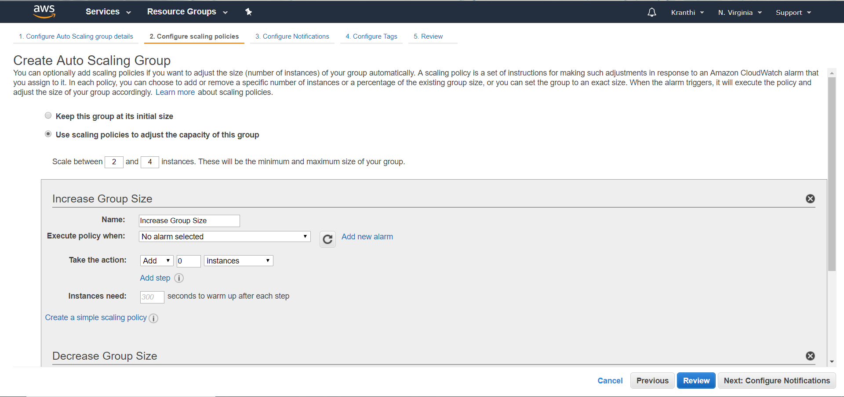

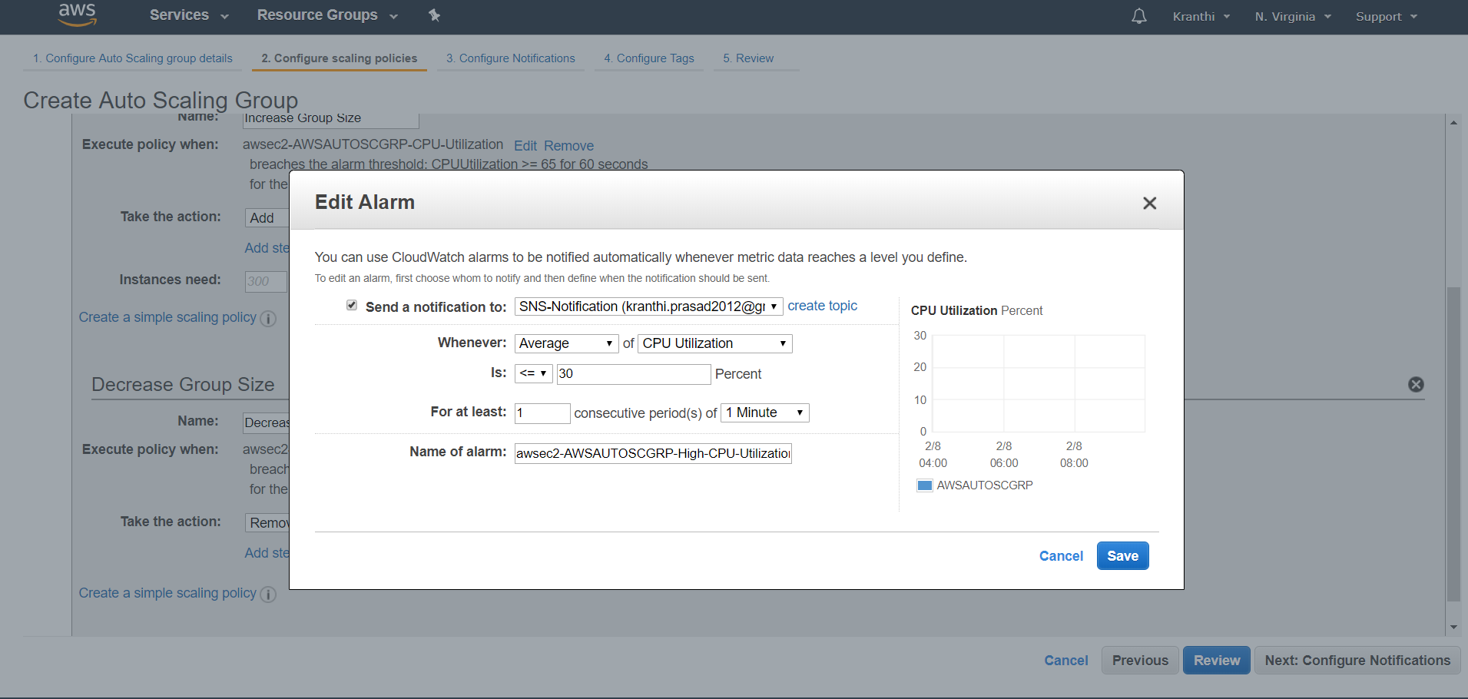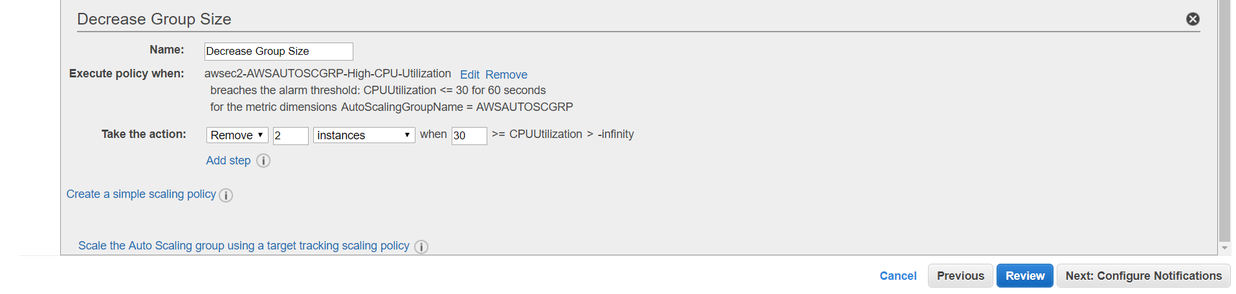

Reviews shows whatever we have added to the auto scaling group.

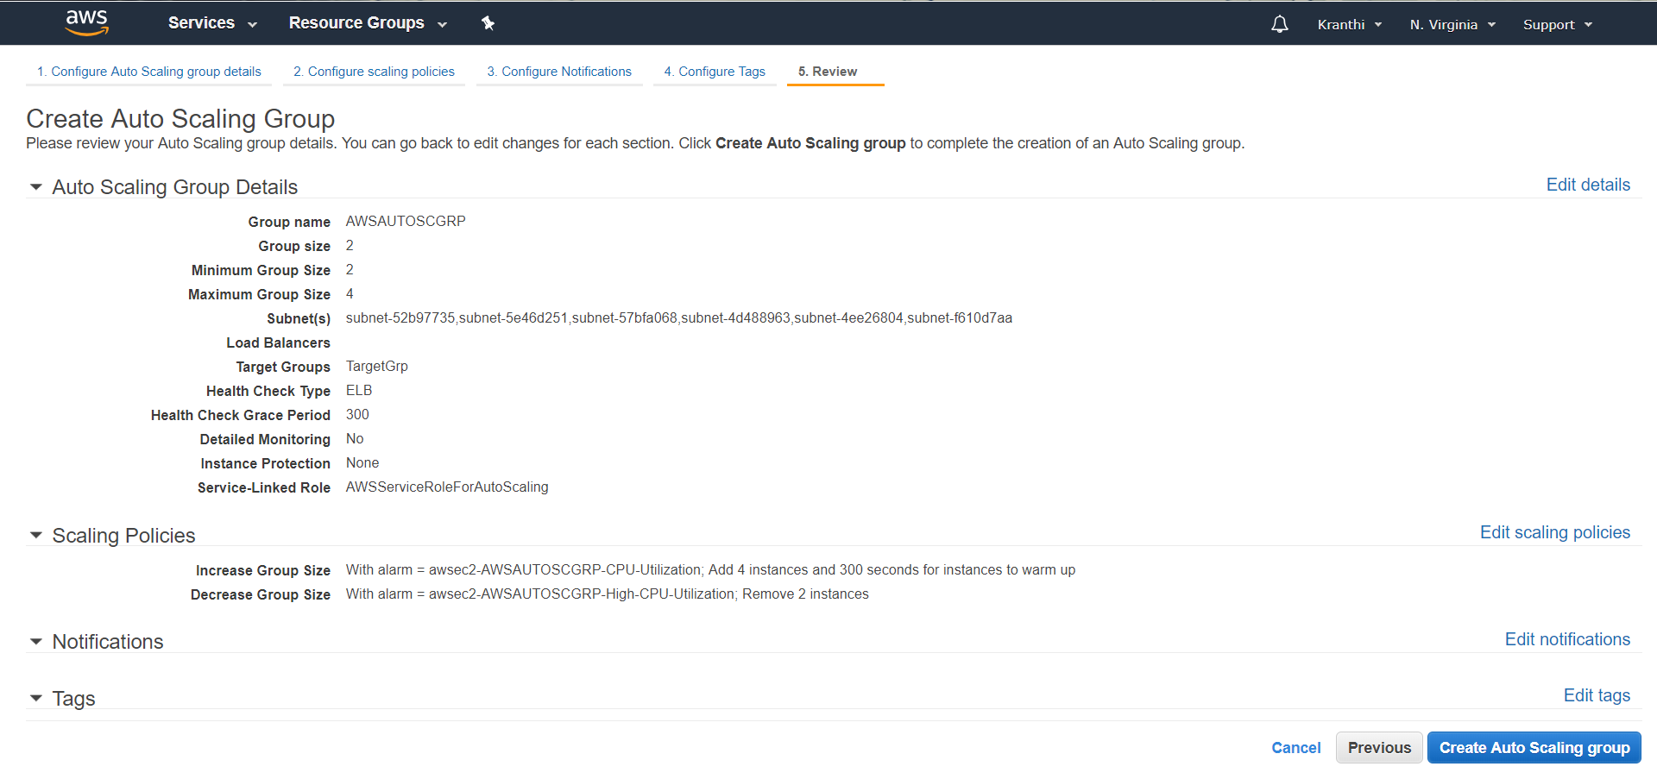

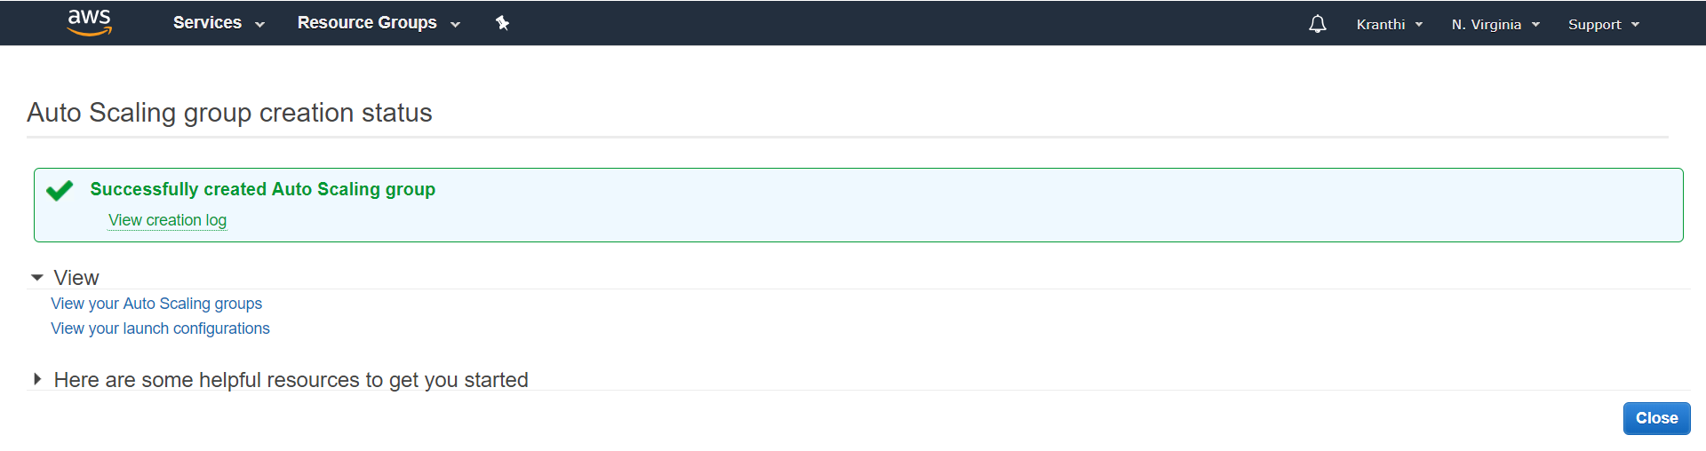

The complete adding of auto-scaling was finished and shows the added one.

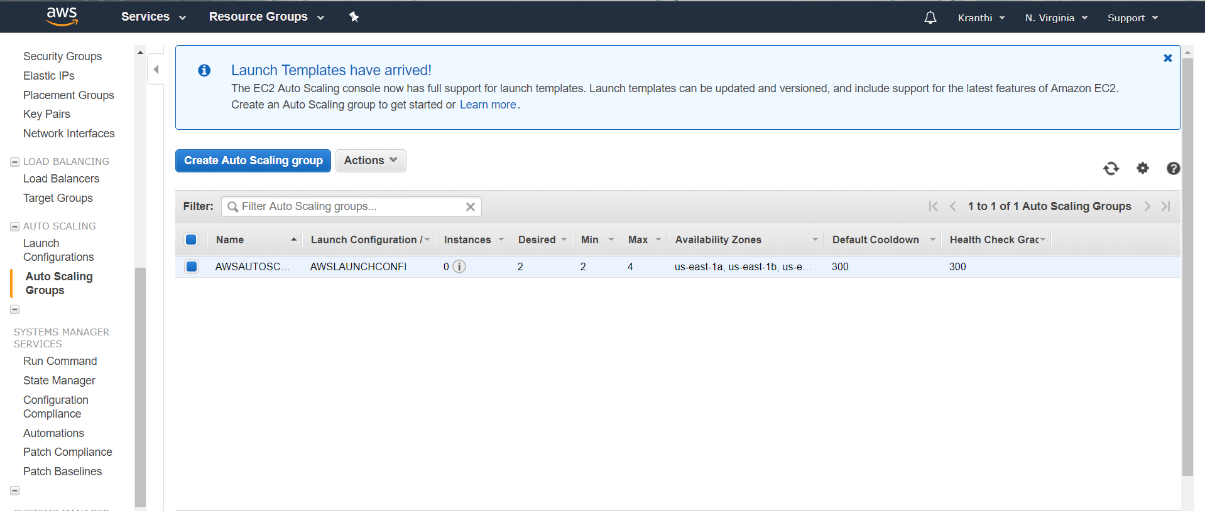

we can notice the automatic addition of new instances, when c.p.u percentage goes high.

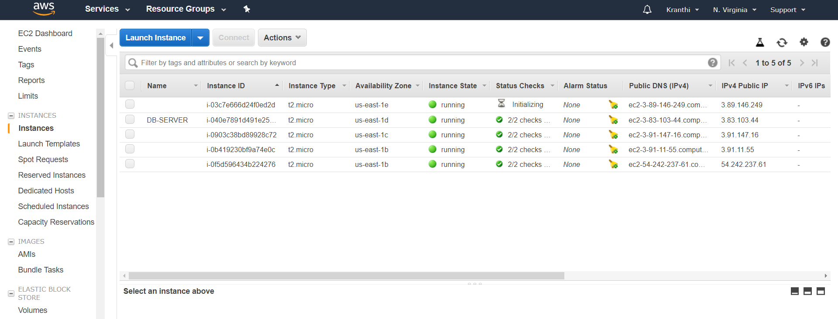

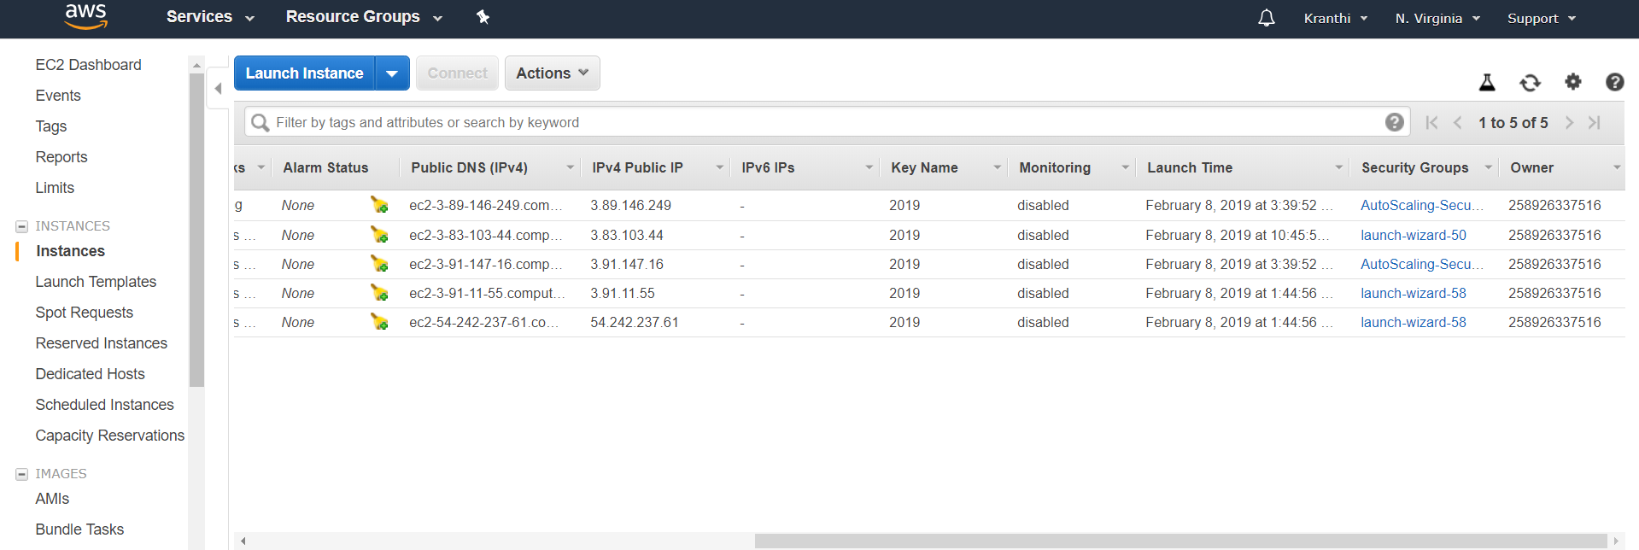

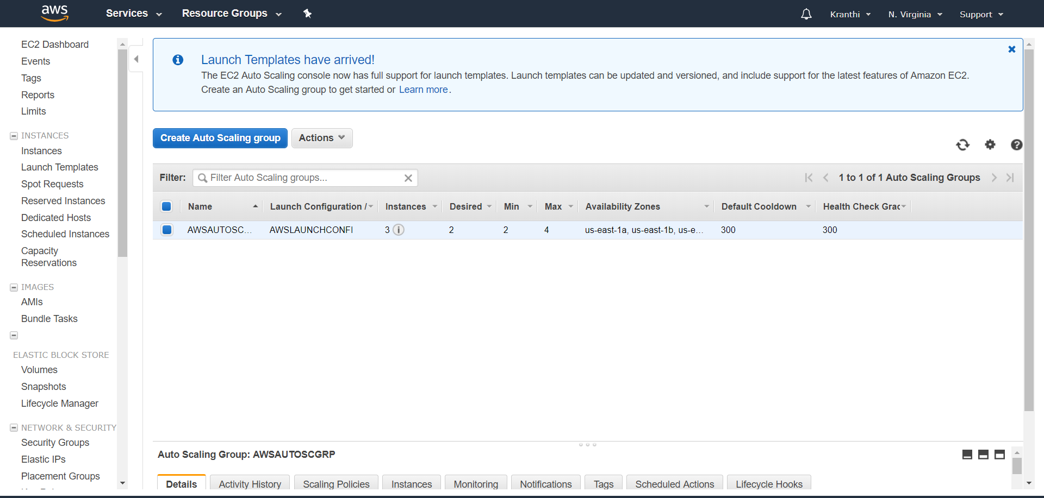

Termination of instances when the C.P.U percentage goes down.

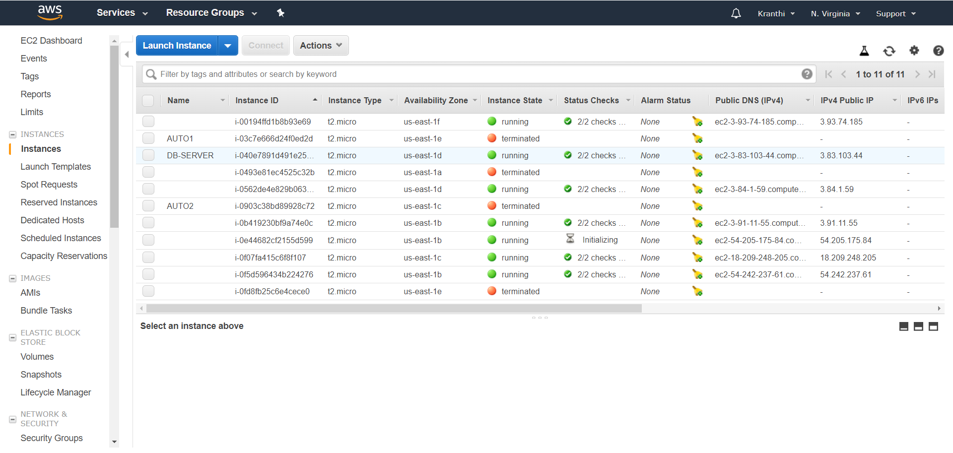

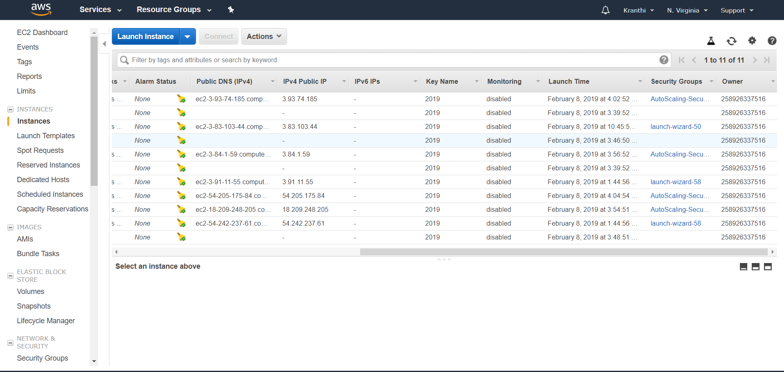

**10 NETWORK SECURITY**

Network security consists of the policies and practices to prevent and monitor unauthorized access, misuse, modification, or denial of a computer network and network-accessible resources. Only Network security can protect you from Trojan horse viruses. Network security involves the authorization of access to data in a system, controlled by the network administrator. To avoid ARP SPOOFING, MAC FLOODING, and DHCP SPOOFING, we implement security policies. Firewall plays a preeminent role in network security. To prevent unauthorized access, we are using Cisco advanced security appliances. To connect different branches with security, we are implementing SITE TO SITE VPN. To overcome the network attacks, we are developing the Intrusion Prevention System. Cisco IOS Intrusion Prevention System (IPS) is an inline, deep-packet inspection feature that effectively mitigates a wide range of network attacks. These network security infrastructure is implementing in On-premises, not in a cloud.

**10.1 DHCP Snooping**

DHCP snooping is a security feature that acts like a firewall between untrusted hosts and

trusted DHCP Servers. The DHCP snooping feature performs the following activities:

* Validates DHCP messages received from untrusted sources and filters out invalid

messages.

* Rate-limits DHCP traffic from trusted and untrusted sources.
* Builds and maintains the DHCP snooping binding database, which contains information about untrusted hosts with leased IP addresses.
* Utilizes the DHCP snooping binding database to validate subsequent requests from

untrusted hosts

**Step by step procedure for implementing DHCP:**

The following steps are required to implement DHCP snooping on your network:

**Step 1.** Define and configure the DHCP server. Configuration of this step does not take

place on the switch or router and is beyond the scope of this book.

**Step 2.** Enable DHCP snooping on at least one VLAN. By default, DHCP snooping is

inactive on all VLANs.

**Step 3.** Ensure that DHCP server is connected through a trusted interface.

By default, the trust state of all interfaces is untrusted.

**Step 4.** Configure the DHCP snooping database agent. This step ensures that database

entries are restored after a restart or switchover.

**Step 5.** Enable DHCP snooping globally

**Implementing DHCP on Switch:**

àEnable DHCP Snooping Globally

sw2(config)# **ip dhcp snooping**

à Enable DHCP Snooping on VLAN 10

sw2(config)# **ip dhcp snooping vlan 10**

à Configure Interface Fa1/0/24 as a Trusted interface

sw2(config)# **interface fa1/0/24**

sw2(config-if)# **ip dhcp snooping trust**

àConfigure the DHCP snooping database agent to store the bindings at a given location

sw2(config)# **exit**

sw2#

Verify DHCP Snooping Configuration

**Output:**

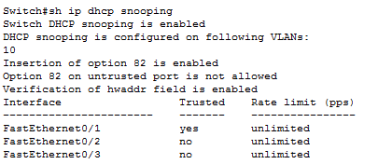

**10.2 Port Security**

How many MAC addresses should legitimately show up inbound on an access port?

Port security controls how many MAC addresses can be learned on a single switch port.

This feature is implemented on a port-by-port basis. A typical user uses just a single MAC

address.

Exceptions to this may be a virtual machine or two that might use different MAC

addresses than their host, or if there is an IP phone with a built-in switch, which may also

account for additional MAC addresses.

In any case, to avoid a user connecting dozens of devices to a switch that is then connected to their access port, you can use port security to limit the number of devices (MAC addresses) on each port.

This also protects against malicious applications that may be sending thousands of frames

into the network, with a different bogus MAC address for each frame, as the user tries to

exhaust the limits of the dynamic MAC address table on the switch, which might cause the

switch to forward all frames to all ports within a VLAN so that the attacker can begin to

sniff all packets. This is referred to as a *CAM table overflow attack*. *Content-addressable*

*memory (CAM)* is a fancy way to refer to the MAC address table on the switch.

**Implementing Port-Security on Switch:**

SW2(config-if)# **interface fa 0/2**

! Enable the feature per interface

SW2(config-if)# **switchport port-security**

! Set the maximum to desired number. Default is 1. If we administratively

! set the maximum to 1, the command won't show in the running configuration

! because the configuration matches the default value. It is handy to know

! this behavior, so you won't be surprised by what may seem to be a missing

! part of your configuration.

SW2(config-if)# **switchport port-security maximum 5**

! Set the violation action. Default is err-disable. Protect will simply

! not allow

! frames from MAC addresses above the maximum.

SW2(config-if)# **switchport port-security violation protect**

This will cause the dynamic mac addresses to be placed into running

! -config to save them to startup config, use copy run start

SW2(config-if)# **switchport port-security mac-address sticky**

! To verify settings, use this command

Output:

Switch#sh port-security

Secure Port MaxSecureAddr CurrentAddr SecurityViolation Security Action

(Count) (Count) (Count)

--------------------------------------------------------------------

Fa0/2 5 1 0 Protect

Fa0/3 5 1 0 Protect

----------------------------------------------------------------------

Switch#

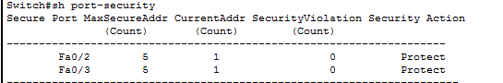

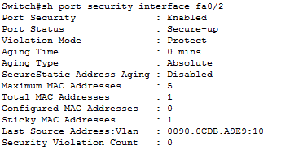

**10.3 Securing the Cisco IOS Image and Configuration Files**

If a router has been compromised, and the flash file system and NVRAM have been deleted,

Then there could be significant downtime as the files are put back in place before restoring normal router functionality. The Cisco Resilient Configuration feature is intended to improve the recovery time by making a secure working copy of the IOS image and startup configuration files (which are referred to as the *primary bootset*) that cannot be deleted by a remote user.

To enable and save the primary bootset to a secure archive in persistent storage, follow Secure the IOS image

R6(config)# **secure boot-image**

%IOS_RESILIENCE-5-IMAGE_RESIL_ACTIVE: Successfully secured running image

! Secure the startup-config

R6(config)# **secure boot-config**

%IOS_RESILIENCE-5-CONFIG_RESIL_ACTIVE: Successfully secured config archive

[flash:.runcfg-20111222-230018.ar]

! Verify the bootset

**Output:**

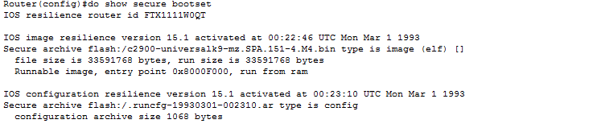

**10.4 ARP Dynamic Inspection**

ARP provides IP communication within a Layer 2 broadcast domain by mapping an IP

address to a MAC address. ARP spoofing attacks and ARP cache poisoning can occur because ARP allows a gratuitous reply from a host even if an ARP request was not received. After the attack, all traffic from the device under attack flows through the attacker’s computer and then to the router, switch, host.

An ARP spoofing attack can target hosts, switches, and routers connected to your Layer

2 network by poisoning the ARP caches of systems connected to the subnet and by intercepting traffic intended for other hosts on the subnet.

DAI is a security feature that validates ARP packets in a network. DAI intercepts, logs, and

discards ARP packets with invalid IP-t o -MAC address bindings. This capability protects the

network from some man-in-the-middle attacks.

DAI determines the validity of an ARP packet based on valid IP-to-MAC address bindings

stored in a trusted database, the DHCP snooping binding database. As described in the previous section, this database is built by DHCP snooping if DHCP snooping is enabled on the VLANs and on the switch. If the ARP packet is received on a trusted interface, the switch

forward the packet without any checks. On untrusted interfaces, the switch forwards the packet only if it is valid.

Enable DAI on VLAN 10

sw2(config)# **ip arp inspection vlan 10**

sw2(config)# **exit**

! Verify DAI Configuration for VLAN 10

sw2# **show ip arp inspection vlan 10**

Source Mac Validation : Disabled

Destination Mac Validation : Disabled

IP Address Validation : Disabled

Vlan Configuration Operation ACL Match Static ACL

---- ------------- --------- --------- ----------

10 Enabled Inactive

Vlan ACL Logging DHCP Logging Probe Logging

---- ----------- ------------ -------------

10 Deny Deny Off

! Configure Interface Fa1/0/24 as a Trusted DAI Interface

sw2(config)# **interface fa1/0/24**

sw2(config-if)# **ip arp inspection trust**

sw2(config-if)# **exit**

sw2(config)# **exit**

sw2# **show ip arp inspection interfaces**

Interface Trust State Rate (pps) Burst Interval

--------------- ----------- ---------- --------------

Fa1/0/1 Untrusted 15 1

Fa1/0/2 Untrusted 15 1

! output removed for brevity

Fa1/0/23 Untrusted 15 1

Fa1/0/24 Trusted None N/A

**10.5 Site to Site VPN**

It helps to connect two different branches or remote locations. It ensures that connectivity between two public networks and with security.

**Implementation Stages:**

Phase 1: Internet security association key management protocols (ISAKMP).

Phase 2: Internet protocol security. It is having ESP and AH.

Phase 3: Interesting traffic will be configured by ACL.

Phase 4: Mapping (Crypto Map).

Phase 5: Apply map on interface.

Here Pre shared key will be used for trust worthiness between two branches.

**Encryption:**

It will convert plain text into cipher text. It classified into 3 types.

1) DES-Data encryption standard

2) 3 DES

3) AES-Advanced encryption standard

**Hash:** It is used for checksum. It is having two types

1) MD5-Message Digest

2) SHA-Secure hashing Algorithm

**Ockley:** It is responsible to carry the message from Router 1 to Router 2.

If we are using both sites of routers are cisco vendors, then it is operated in main mode, in this 6 messages will be exchanged. For different vendors of router in both sites, it will be operated in Aggressive Mode only 3 messages exchanged.

In this VPN, we have 2 Tunnels. Those are

1) ISAKMP

2) IPSEC

**ISAKMP:** By using this tunnel session keys will be exchanged, this was generated by the **Diffie**–**Hellman** Algorithm. ISAKMP tunnel is responsible for IPSEC tunnel up and running.

**IPSEC:** This tunnel is used for actual data transmission. ESP and AH are responsible to carry data in IPSEC tunnel.

**Crypto Map:** It is used to identify the router the packet belongs to which network. Only one crypto map can be applied for single interface.

**HMac:** Hmac is used for sequence number and to add the Tags.

**VPN CONFIGURATION:**

Router-1

crypto isakmp policy 10

encr 3des

hash md5

authentication pre-share

group 2

crypto isakmp key cisco address 1.1.1.2

crypto isakmp key juniper address 1.1.1.3

!

!

crypto ipsec transform-set dell esp-3des esp-md5-hmac

crypto ipsec transform-set lenovo esp-aes esp-sha-hmac

!

crypto map irfan 110 ipsec-isakmp

set peer 1.1.1.2

set transform-set dell

match address 101

crypto map irfan 111 ipsec-isakmp

set peer 1.1.1.3

set transform-set lenovo

match address 102

!

interface Loopback0

ip address 10.1.1.1 255.0.0.0

!

interface FastEthernet0/0

ip address 1.1.1.1 255.0.0.0

duplex auto

speed auto

crypto map irfan

!

interface FastEthernet0/1

no ip address

shutdown

duplex auto

speed auto

!

ip route 0.0.0.0 0.0.0.0 FastEthernet0/0

!

no ip http server

no ip http secure-server

!

access-list 101 permit ip host 10.1.1.1 host 20.1.1.1

access-list 101 permit ip host 1.1.1.1 host 1.1.1.2

access-list 102 permit ip host 10.1.1.1 host 30.1.1.1

!

control-plane

!

line con 0

exec-timeout 0 0

privilege level 15

logging synchronous

line aux 0

exec-timeout 0 0

privilege level 15

logging synchronous

line vty 0 4

login

!

!

End

**Router-2**

crypto isakmp policy 10

encr 3des

hash md5

authentication pre-share

group 2

crypto isakmp key cisco address 1.1.1.1

!

!

crypto ipsec transform-set dell esp-3des esp-md5-hmac

!

crypto map irfan 110 ipsec-isakmp

set peer 1.1.1.1

set transform-set dell

match address 101

!

!

!

!

!

interface Loopback0

ip address 20.1.1.1 255.0.0.0

!

interface FastEthernet0/0

ip address 1.1.1.2 255.0.0.0

duplex auto

speed auto

crypto map irfan

!

interface FastEthernet0/1

no ip address

shutdown

duplex auto

speed auto

!

ip route 0.0.0.0 0.0.0.0 1.1.1.1

!

no ip http server

no ip http secure-server

!

access-list 101 permit ip host 20.1.1.1 host 10.1.1.1

access-list 101 permit ip host 1.1.1.2 host 1.1.1.1

!

!

control-planel!

!

line con 0

exec-timeout 0 0

privilege level 15

logging synchronous

line aux 0

exec-timeout 0 0

privilege level 15

logging synchronous

line vty 0 4

login

End

**OUTPUT**

R1#sh crypto isakmp sa

dst src state conn-id slot status

1.1.1.2 1.1.1.1 QM_IDLE 1 0 ACTIVE

R1#sh crypto ipsec sa

interface: FastEthernet0/0

Crypto map tag: irfan, local addr 1.1.1.1

protected vrf: (none)

local ident (addr/mask/prot/port): (1.1.1.1/255.255.255.255/0/0)

remote ident (addr/mask/prot/port): (1.1.1.2/255.255.255.255/0/0)

current_peer 1.1.1.2 port 500

PERMIT, flags={origin_is_acl,}

#pkts encaps: 0, #pkts encrypt: 0, #pkts digest: 0

#pkts decaps: 0, #pkts decrypt: 0, #pkts verify: 0

#pkts compressed: 0, #pkts decompressed: 0

#pkts not compressed: 0, #pkts compr. failed: 0

#pkts not decompressed: 0, #pkts decompress failed: 0

#send errors 0, #recv errors 0

local crypto endpt.: 1.1.1.1, remote crypto endpt.: 1.1.1.2

path mtu 1500, ip mtu 1500

current outbound spi: 0x0(0)

inbound esp sas:

inbound ah sas:

inbound pcp sas:

outbound esp sas:

outbound ah sas:

outbound pcp sas:

protected vrf: (none)

local ident (addr/mask/prot/port): (10.1.1.1/255.255.255.255/0/0)

remote ident (addr/mask/prot/port): (20.1.1.1/255.255.255.255/0/0)

current_peer 1.1.1.2 port 500

PERMIT, flags={origin_is_acl,}

#pkts encaps: 14, #pkts encrypt: 14, #pkts digest: 14

#pkts decaps: 14, #pkts decrypt: 14, #pkts verify: 14

#pkts compressed: 0, #pkts decompressed: 0

#pkts not compressed: 0, #pkts compr. failed: 0

#pkts not decompressed: 0, #pkts decompress failed: 0

#send errors 6, #recv errors 0

local crypto endpt.: 1.1.1.1, remote crypto endpt.: 1.1.1.2

path mtu 1500, ip mtu 1500

current outbound spi: 0x65DCEB8B(1708977035)

inbound esp sas:

spi: 0xDA81E22F(3665945135)

transform: esp-3des esp-md5-hmac ,

in use settings ={Tunnel, }

conn id: 2004, flow_id: SW:4, crypto map: irfan

sa timing: remaining key lifetime (k/sec): (4441307/3533)

IV size: 8 bytes

replay detection support: Y

Status: ACTIVE

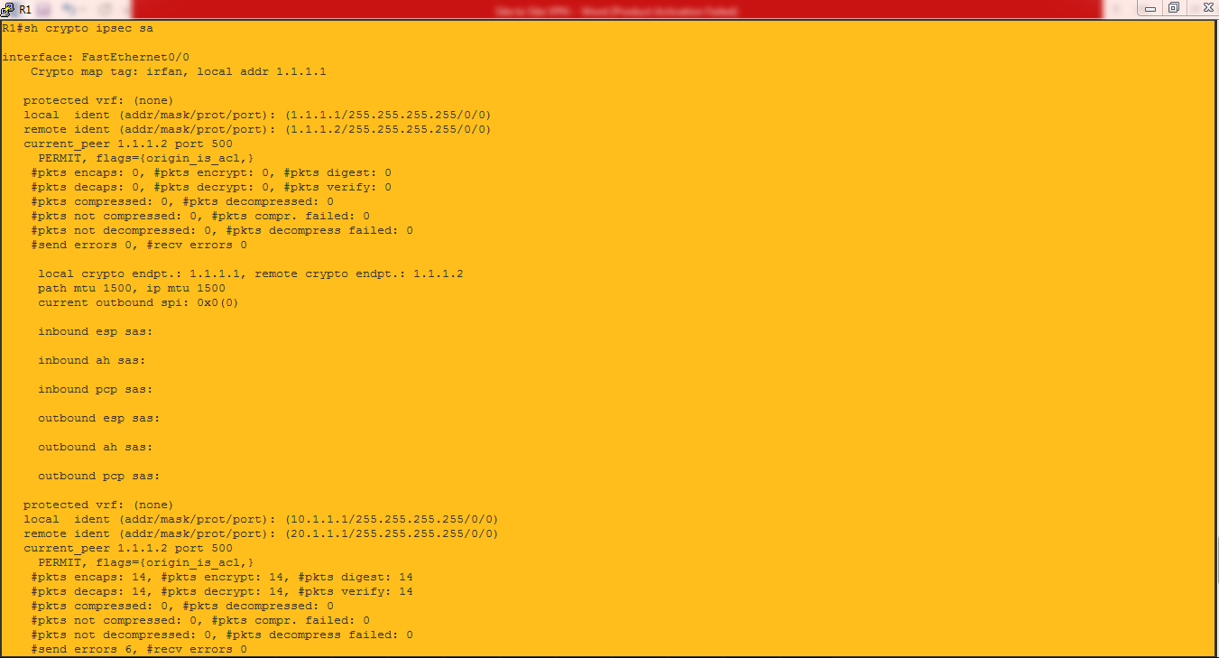

Conclusion: